Group A

Assignment Number 4

PL/SQL

**Problem Statement:**

Unnamed PL/SQL code block: Use of Control structure and Exception handling is mandatory.

Schema:

1. Borrower(Roll_no, Name, Dateoflssue, NameofBook, Status)

2. Fine(Roll no,Date, Amt) Accept roll no & name of book from user.

Check the number of days (from date of issue), if days are between 15 to 30 then fine amount will be Rs Sper day.

If no, of days 30, per day fine will be Rs 50 per day & for days less than 30, Rs. 5 per day. After submitting the book, status will change from I to R.

If condition of fine is true, then details will be stored into fine table.

**PROGRAM INPUT**

CREATE TABLE BORROWER

(

roll no NUMBER,

name VARCHAR2(25),

dateofissue DATE,

name_of_book VARCHAR2(25),

status VARCHAR2(20)

);

CREATE TABLE FINE

(

Roll_no NUMBER,

date_of_return DATE,

amt NUMBER

);

INSERT INTO borrower VALUES (54, ‘SUDARSHAN’, TO_DATE ('01-10-2022, DD-MM-YYYY'),

'HARRY POTTER','I’);

INSERT INTO borrower VALUES(56,'SUMIT’, TO_DATE(‘15-10-2022','DD-MM-YYYY'),

’DARK MATTER','I');

INSERT INTO borrower VALUES(68, 'MANDAR’, TO_DATE(‘24-09-2022','DD-MM- YYYY'),

'SILENT HILL','I');

INSERT INTO borrower VALUES(66, 'SIDDHAM”, TO_DATE(26-08-2022','DD-MM- YYYY'),

'GOD OF WAR',’I’);

INSERT INTO borrower VALUES(50,'SHREYAS',TO_DATE(09-09-2022','DD-MM-YYYY'),

'SPIDER-MAN','I');

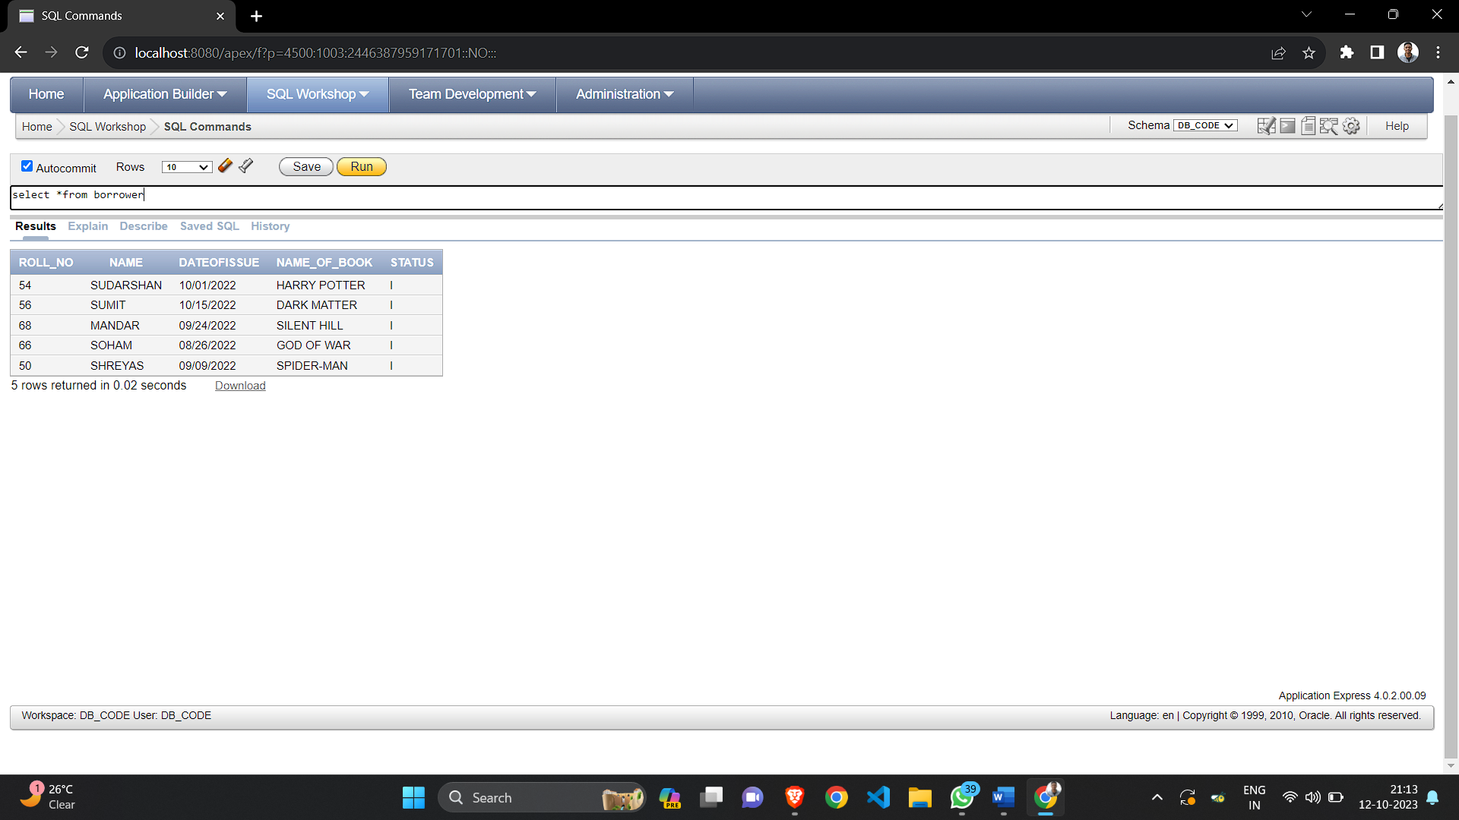

DECLARE

i_roll_no NUMBER: 54;

name of book VARCHAR2(25);

no_of_days NUMBER;

return_date DATE: TO_DATE(SYSDATE, 'DD-MM-YYYY');

temp NUMBER;

doi DATE;

fine NUMBER;

BEGIN

i_roll_no := i_roll_no;

name_of_book: '&nameofbook';

--dbms_output.put_line(return_date);

SELECT to_date(borrower.dateofissue, 'DD-MM-YYYY’) INTO doi FROM borrower

WHERE borrower.roll_no := i_roll_no AND borrower.name_of_book=name_of_book;

no_of days := return date-doi;

dbms_output.put_line(no_of_days);

IF (no_of_days > 15 AND no_of_days <=30) THEN

fine: 5 no_of_days;

ELSIF (no_of_days>30) THEN

temp=no_of_days-30;

fine := 150+ temp*50;

END IF:

dbms_output.put_line(fine);

INSERT INTO fine VALUES(i_roll_no.return_date,fine); UPDATE borrower SET status = 'R' WHERE borrower.roll_no=i_roll_no;

END;

FINE TABLE AFTER SUBMITTING :

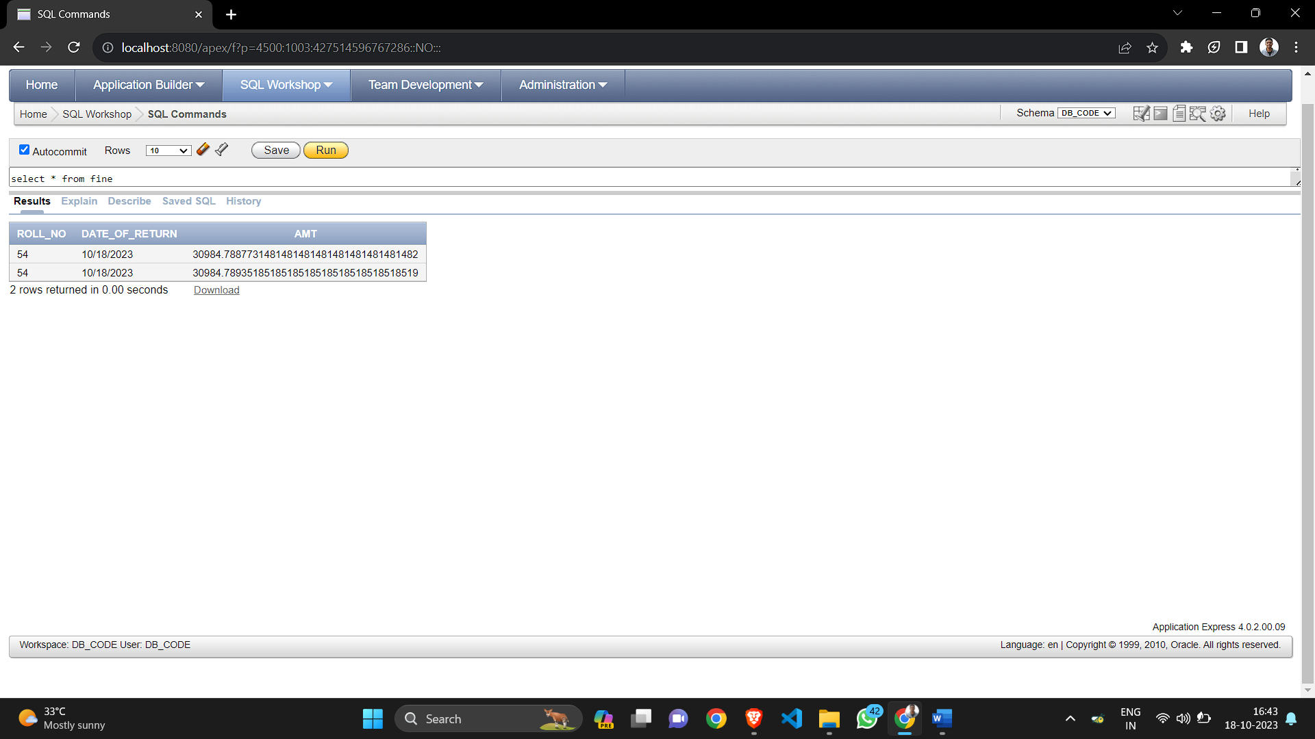

BORROWER TABLE AFTER SUBMITTING :

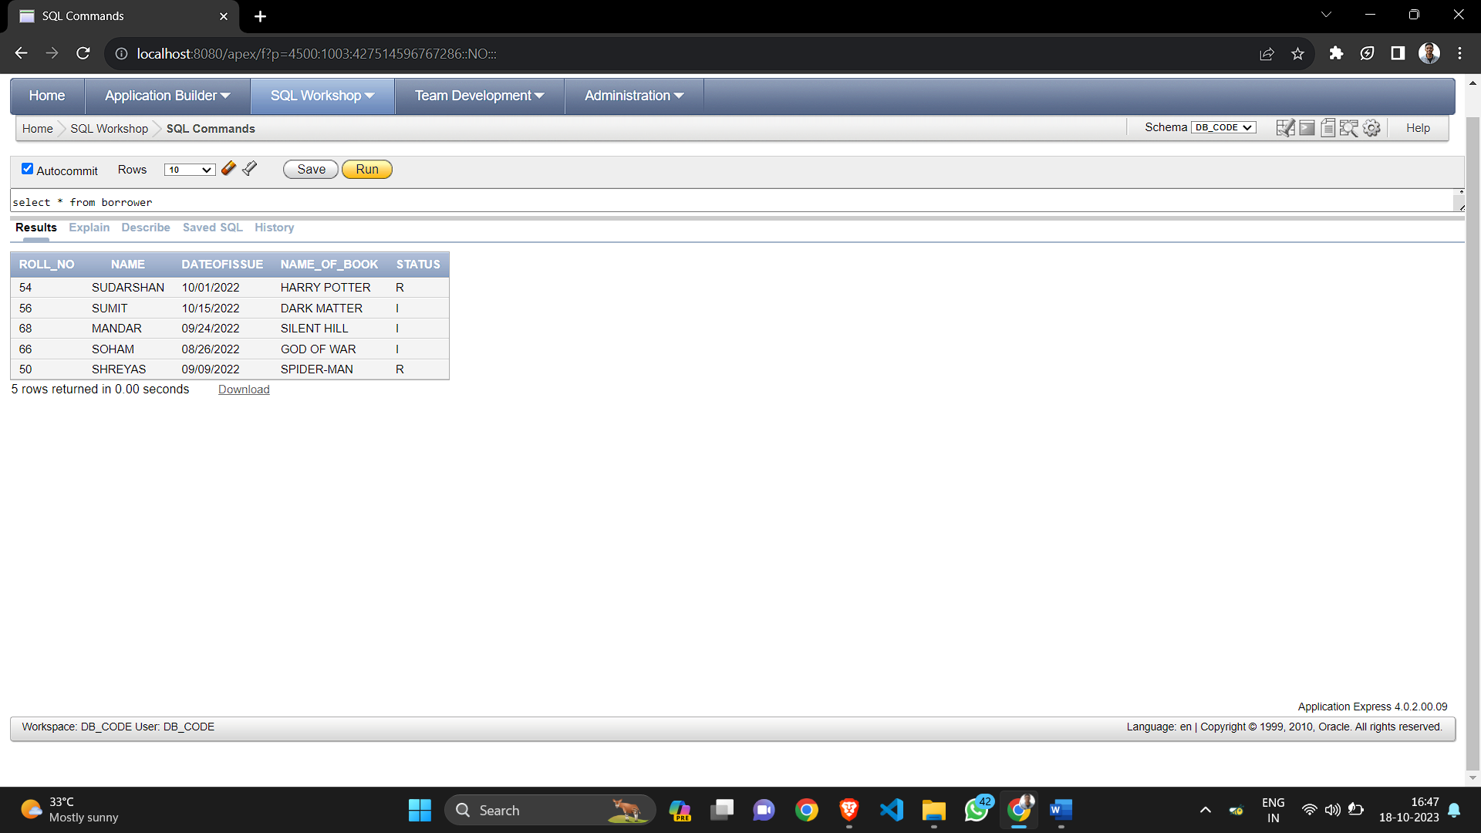

Group A

Assignment Number 5

PL/SQL

**Problem Statement:**

Write a a PL/SQL code block to calculate the area of a circle for a value of radius varying from 5 to . Store the radius and the corresponding values of calculated area in an empty table named areas, consisting of two columns, radius and area.

Lab Exercise:

**1.** Write a PL/SQL code block to calculate the area of a circle for a value of radius varying from 6 to 10. Store the radius and the corresponding values of calculated area in an empty table named areas, consisting of two columns, radius and area.

**2.** Write a PL/SQL code block to calculate the area of a circle for a value of radius varying from 10 to 15. Store the radius and the corresponding values of calculated area in an empty table named areas, consisting of two columns, radius and area.

**3.** Write a PL/SQL code block to calculate the area of a circle for a value of radius varying from 4 to 9. Store the radius and the corresponding values of calculated area in an empty table named areas, consisting of two columns, radius and area.

PROGRAM INPUT & OUTPUT

CREATE TABLE AREAS

(

RADIUS NUMBER(5),

AREA NUMBER(14,2)

);

DECLARE

pi constant number(4,2) := 3.14;

area number(14,2);

radius number(5);

BEGIN

Radius := 5;

while radius <= 9

loop

area := pi*power(radius,2);

insert into areas values(radius,area);

radius := radius+1;

end loop;

end;

SELECT *FROM AREAS;

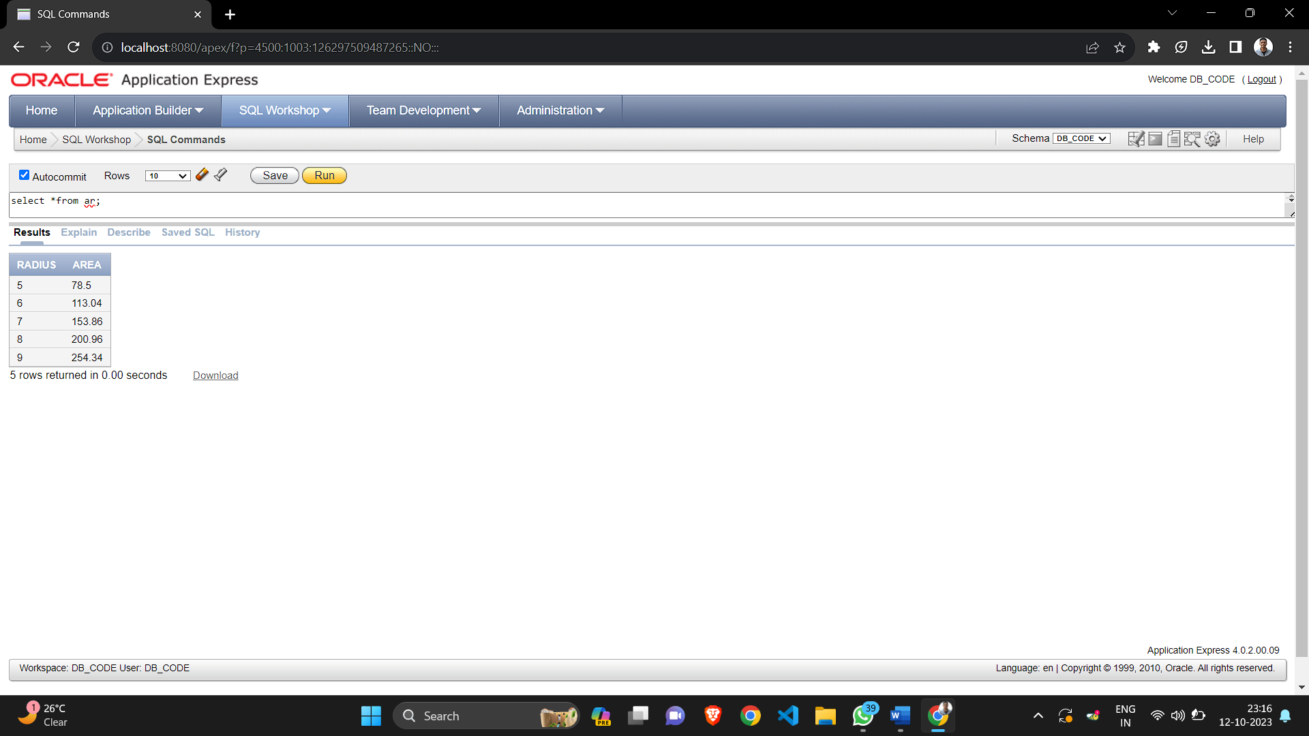

CREATE TABLE AREAS

(

RADIUS NUMBER(5),

AREA NUMBER(14,2)

);

DECLARE

pi constant number(4,2) := 3.14;

area number(14,2);

radius number(5);

BEGIN

Radius := 6;

while radius <= 10

loop

area := pi*power(radius,2);

insert into areas values(radius,area);

radius := radius+1;

end loop;

end;

SELECT *FROM AREAS

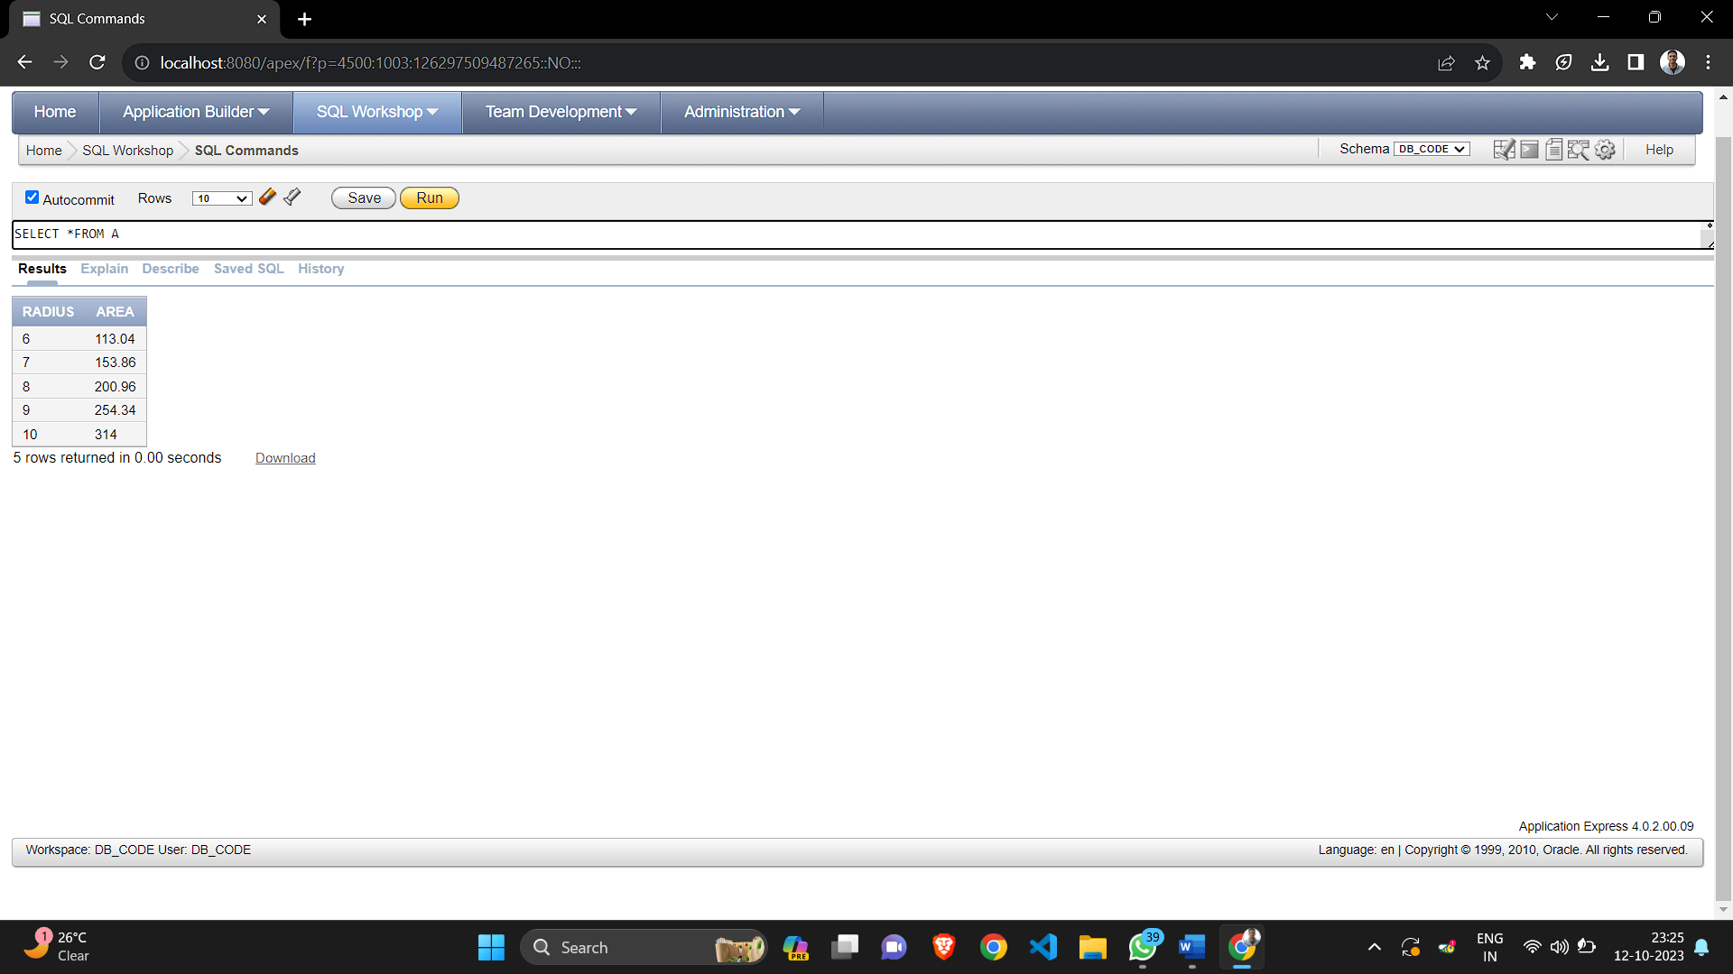

CREATE TABLE AREAS

(

RADIUS NUMBER(5),

AREA NUMBER(14,2)

);

DECLARE

pi constant number(4,2) := 3.14;

area number(14,2);

radius number(5);

BEGIN

Radius := 10;

while radius <= 15

loop

area := pi*power(radius,2);

insert into areas values(radius,area);

radius := radius+1;

end loop;

end;

SELECT *FROM AREAS

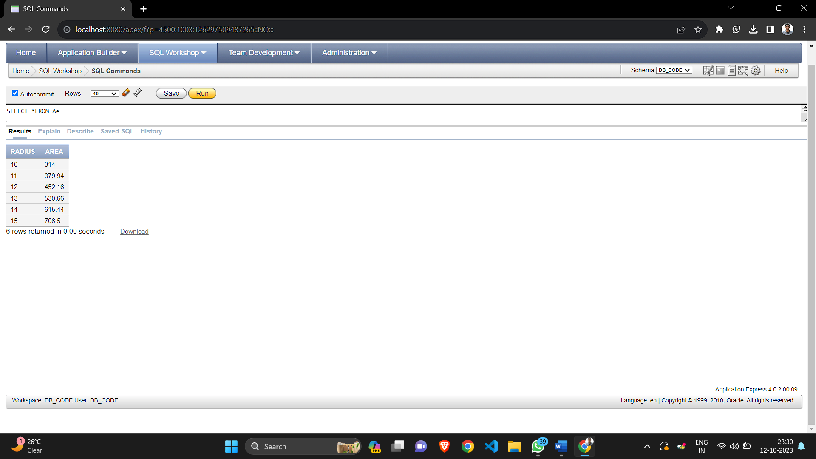

Group A

Assignment Number 6

PL/SQL

**Problem Statement:**

Named PL/SQL Block: PL/SQL Stored Procedure and Stored Function.

Write a Stored Procedure namely proc Grade for the categorization of student. If marks scored by students in examination is 1500 and marks-990then student will be placed in distinction category if marks scored are between 989 and900 category is first class, if marks 899 and 825 category is Higher Second Class. Write a PL/SQL block for using procedure created with above requirement. Stud Marks(name, total marks) Result(Roll Name, Class).

PROGRAM INPUT

CREATE TABLE stud marks

(

name VARCHAR2(25),

total_marks NUMBER

);

CREATE TABLE result

(

roll_number NUMBER,

name VARCHAR2(25),

class VARCHAR2(30)

);

CREATE OR REPLACE PROCEDURE procedure 1 (roll no IN NUMBER, name IN VARCHAR2 marks IN NUMBER)

AS

BEGIN

IF (marks<=1500 and marks>=990) THEN

DBMS_OUTPUT.PUT LINE (roll_no||" - "||name||’ : DISTINCTION");

INSERT INTO result VALUES (roll_no,name, ‘DISTINCTION’);

ELSIF (marks<=989 and marks>=900) THEN

DBMS_OUTPUT.PUT_LINE (roll_no||’-‘||name||’ : FIRST CLASS');

INSERT INTO result VALUES (roll no,name, 'FIRST CLASS');

ELSIF (marks<=899 and marks>825) THEN

DBMS_OUTPUT.PUT_LINE(roll_no||"-"||name||’: HIGHER SECOND CLASS');

INSERT INTO result VALUES (roll_no,name, 'HIGHER SECOND CLASS');

ELSE

DBMS_OUTPUT.PUT_LINE (roll_no||’-‘||name||’: FAIL');

INSERT INTO result VALUES (roll_no,name, 'FAIL'); END IF;

END IF;

INSERT INTO stud_marks VALUES (name,marks);

END procedure_1;

BEGIN

Procedure_1(54,’ SUDARSHAN’,1000);

Procedure_1(46,'ARYAN’, 1950).

Procedure_1(58,'ARJUN’, 1050);

Procedure_1(48,'SARTHAK ',750);

END;

**OUTPUT:**

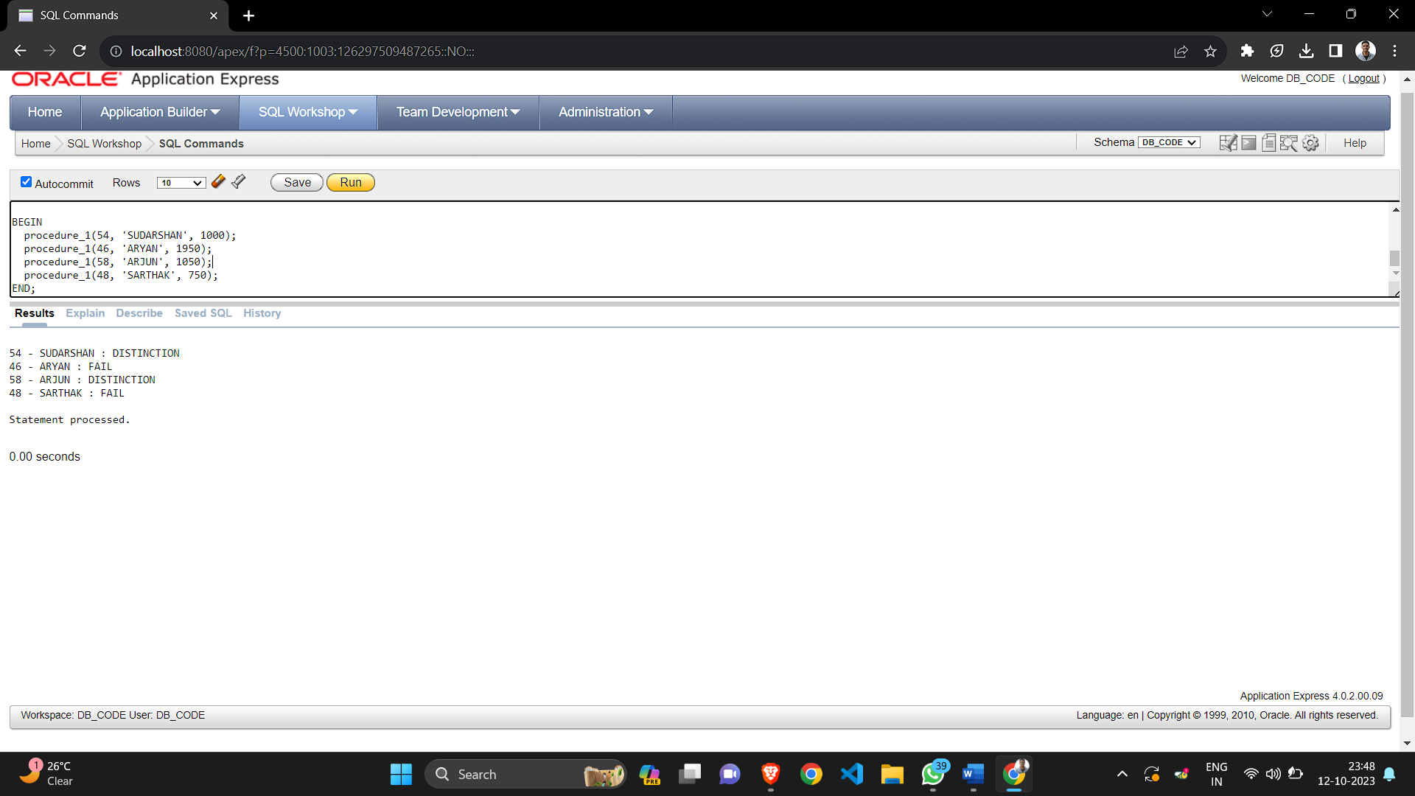

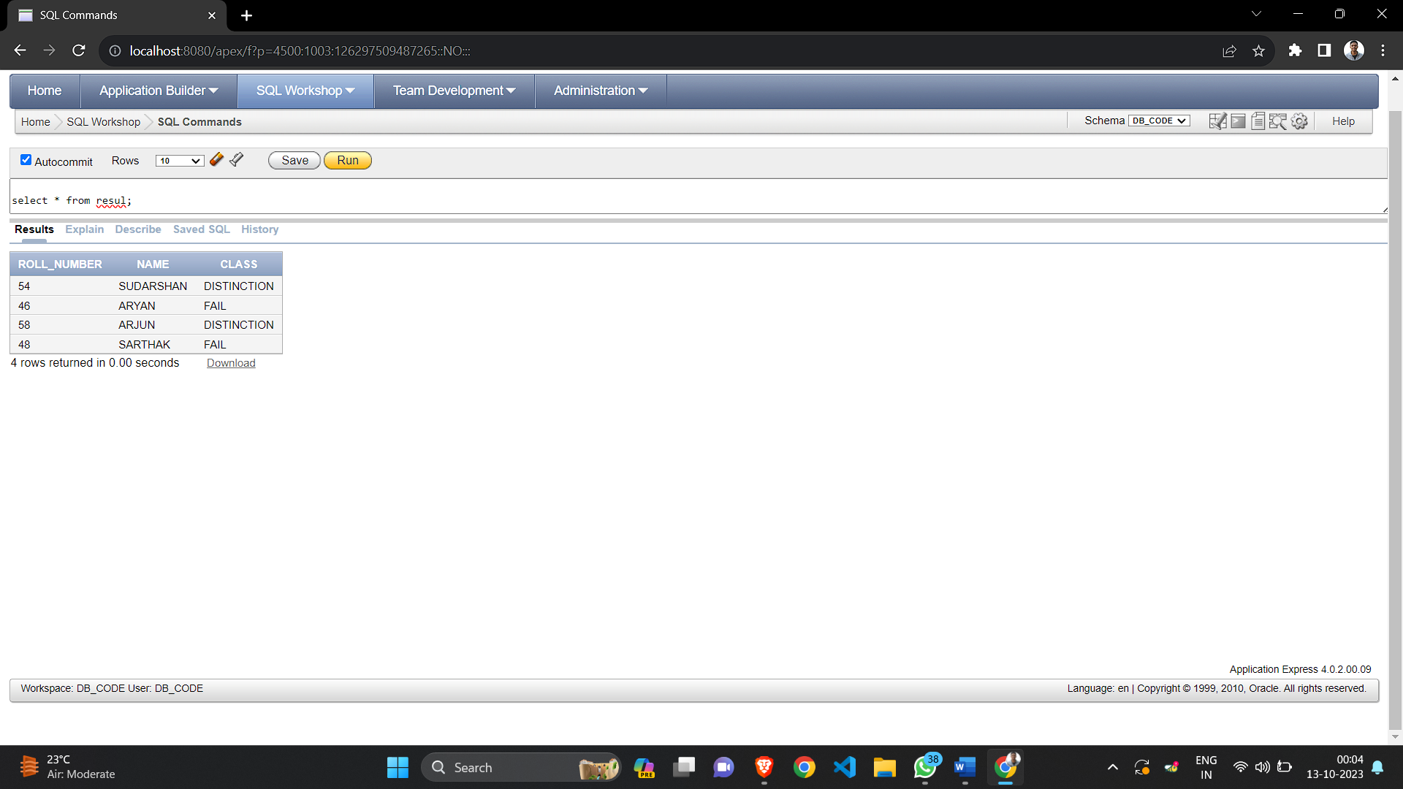

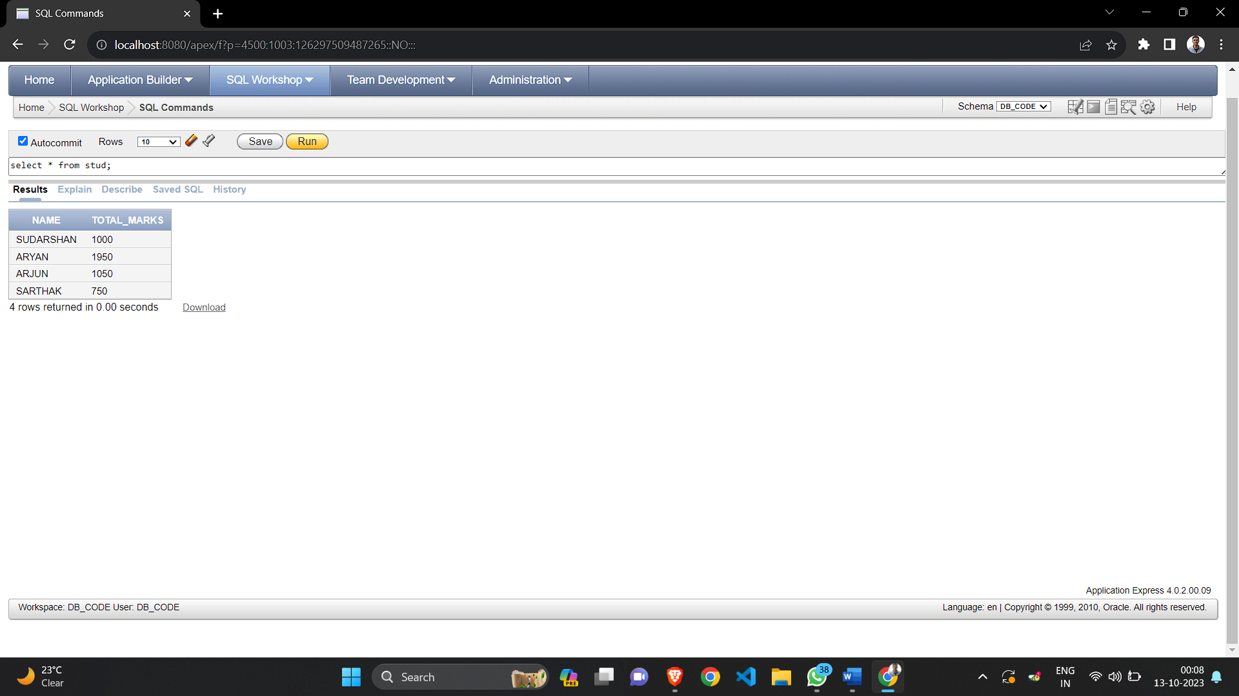

Group A

Assignment Number 7

Cursors

**Problem Statement:**

cursors: (All types: Implicit, Explicit, Cursor FOR Loop, Parameterized Cursor)

Write a PL/SQL block of code using parameterized Cursor, that will merge the data available in the newly created table Cust New with the data available in the table Cust Old. If the data in the first table already exist in the second table then that data should be skipped.

PROGRAM INPUT & OUTPUT

CREATE TABLE Cust _New

(

Name VARCHAR2(15)

);

INSERT INTO Cust_New VALUES (“ABC");

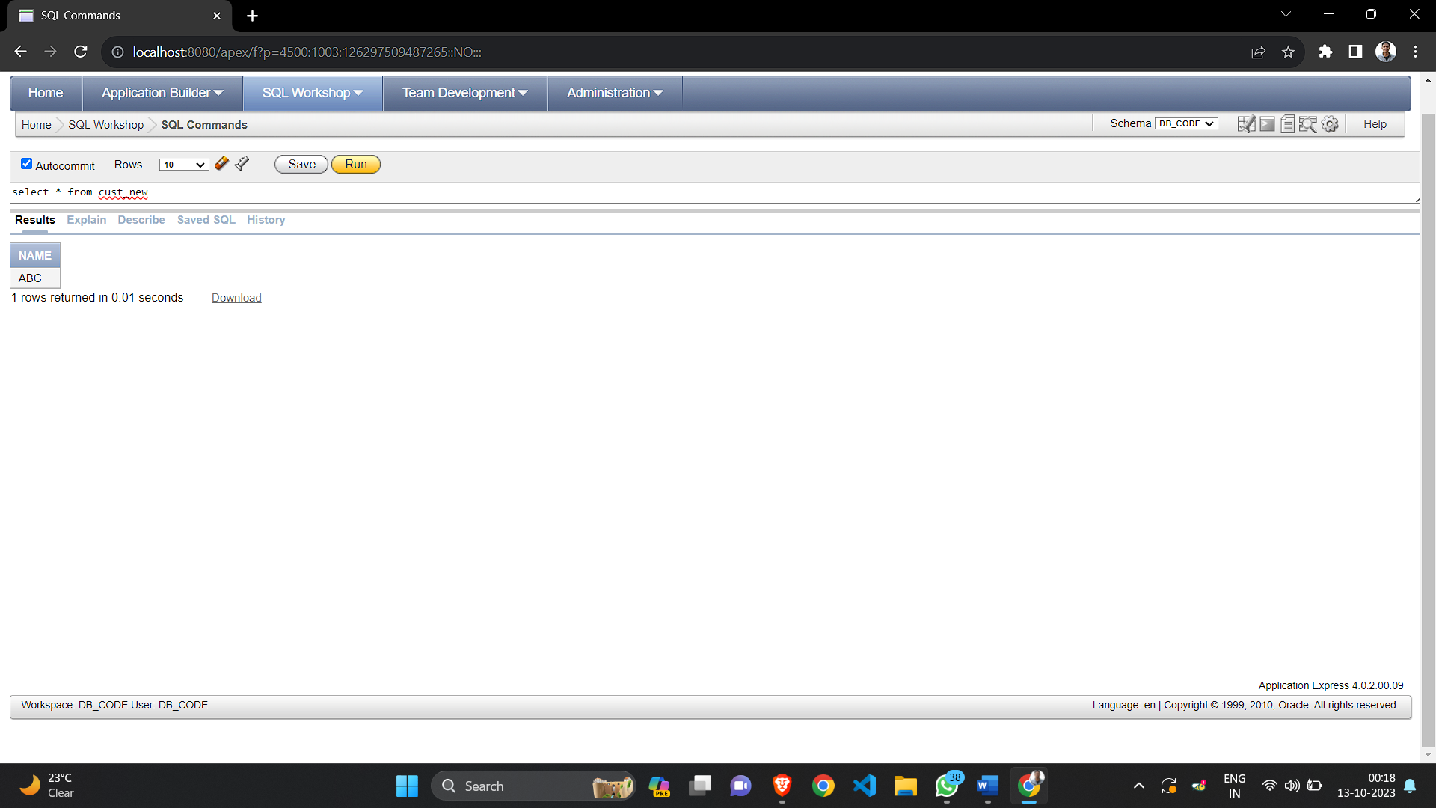

CREATE TABLE Cust_Old

(

Name VARCHAR2(15)

);

INSERT INTO Cust Old VALUES (‘ABC’);

INSERT INTO Cust Old VALUES (‘PQR’);

INSERT INTO Cust Old VALUES (‘XYZ’);

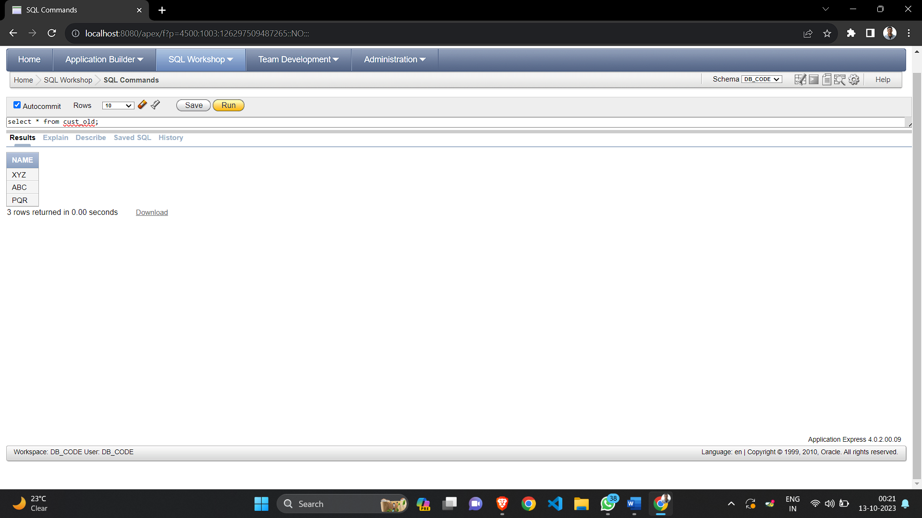

DECLARE

CURSOR cur1 IS

SELECT Name from Cust_Old;

CURSOR cur2 IS

SELECT Name from Cust_New;

R VARCHAR(15);

C_Name VARCHAR(15);

BEGIN

OPEN cur1;

OPEN cur2;

LOOP

Fetch cur1 into C_Name;

Fetch cur2 into R;

EXIT WHEN cur1%FOUND = FALSE;

IF R <> C_Name THEN

INSERT INTO Cust_New VALUES (C_Name);

END IF;

END LOOP;

CLOSE cur1;

END;

SELECT * FROM Cust_New;

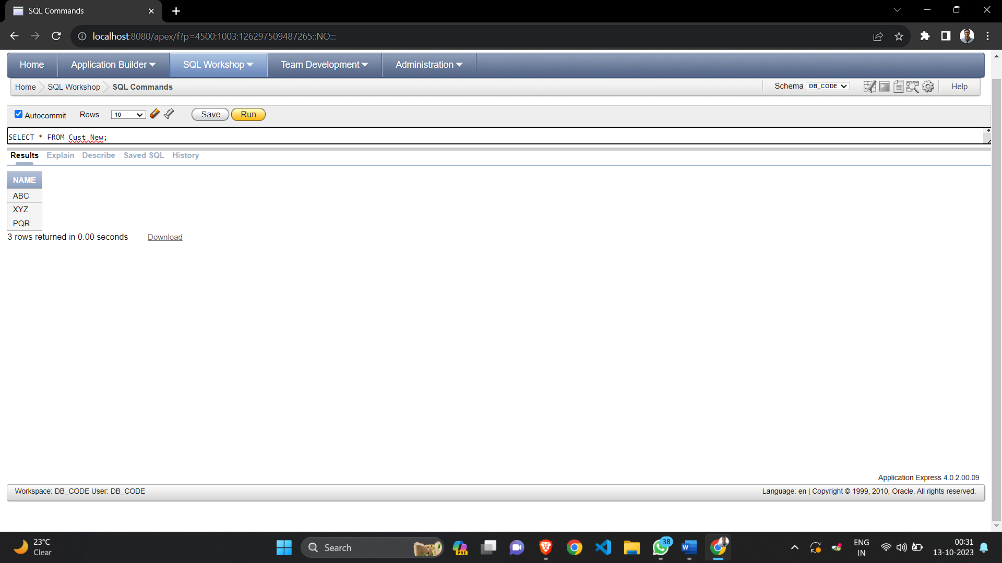

Group A

Assignment Number 8

Trigger

**Problem Statement:**

Database Trigger (All Types: Row level and Statement level triggers, Before and After Triggers). Write a database trigger on Library table. The System should keep track of the records that are being updated or deleted. The old value of updated or deleted records should be added in Library Audit table.

PROGRAM INPUT

**---Table Creation**

CREATE TABLE Library

(

Book_Id NUMBER(5),

Book_Name VARCHAR2(20),

Book_Type VARCHAR2(20),

Issued_By VARCHAR2(20)

):

:**Table Insertion**

INSERT INTO Library VALUES (1234, ‘DBMS', 'Reference','Sudarshan');   
INSERT INTO Library VALUES (1836, ‘TOC’, ‘Text’, Siddham');

INSERT INTO Library VALUES (1996, ‘SPOS', 'Reference', 'Shreyas');

INSERT INTO Library VALUES (1196, ‘CNS', ‘Text’, ‘Sairaj');

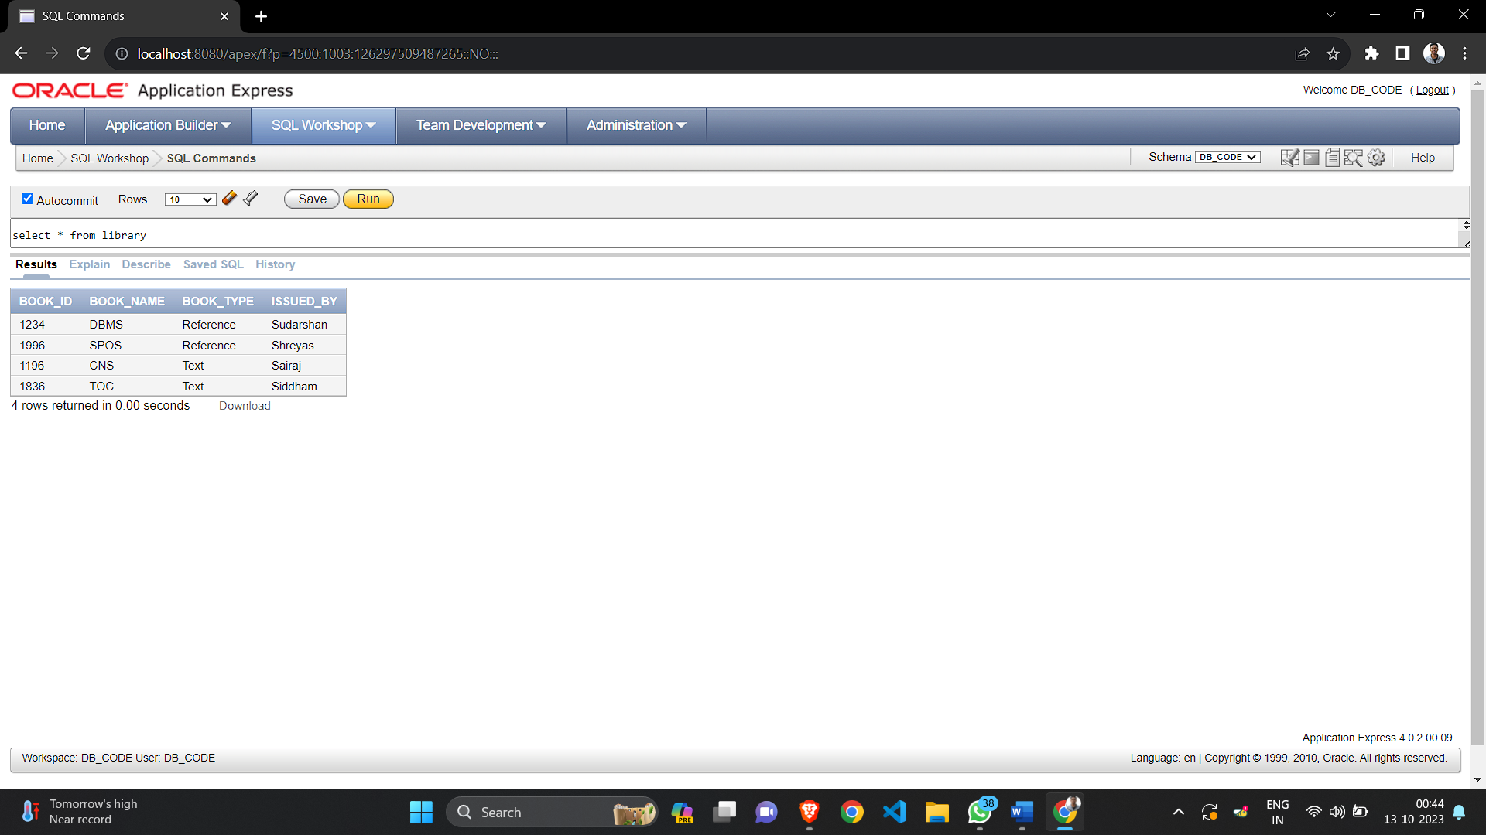

**;Table Creation**

CREATE TABLE Back_UP

(

Book_Id NUMBER(5),

Book_Name VARCHAR2(20),

Book_Type VARCHAR2(20),

Issued_By VARCHAR2(20)

);

**: Trigger Creation**

CREATE TRIGGER Update_Rec

AFTER UPDATE OR DELETE ON Library

FOR EACH ROW

BEGIN

INSERT INTO Back_UP (Book_Id, Book_Name, Book Type, Issued By) VALUES

(cold.Book_Id, :old.Book_Name, :old.Book_Type, :old.Issued_By);

END;

UPDATE LIBRARY

SET Issued By = 'Sairaj'

WHERE Issued By = 'Sumit';

SELECT FROM Back_UP;

**Assignment 2(a) – DDL**

1. **Trains table created**

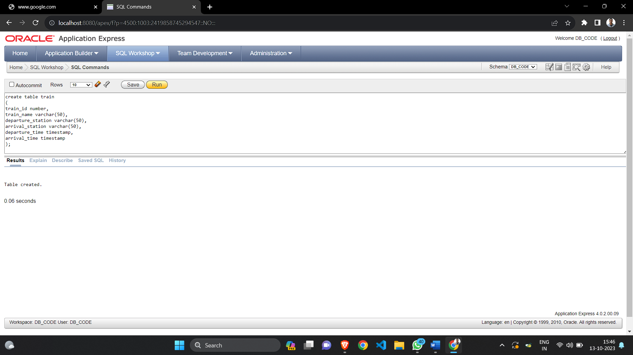

1. **Station table created**

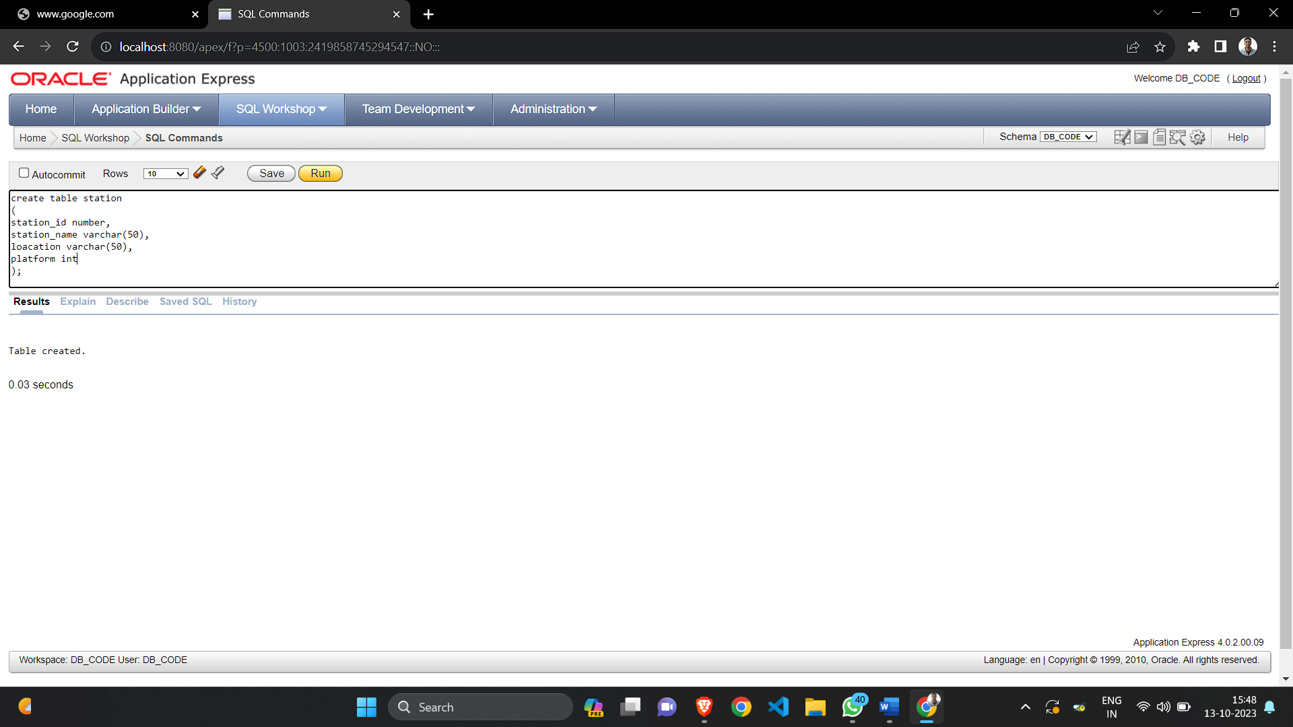

1. **Passenger table created**

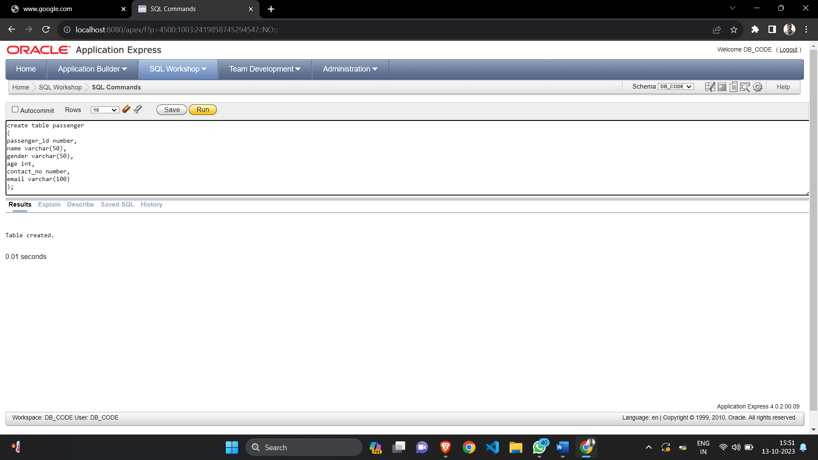

1. **Ticket prices table created**

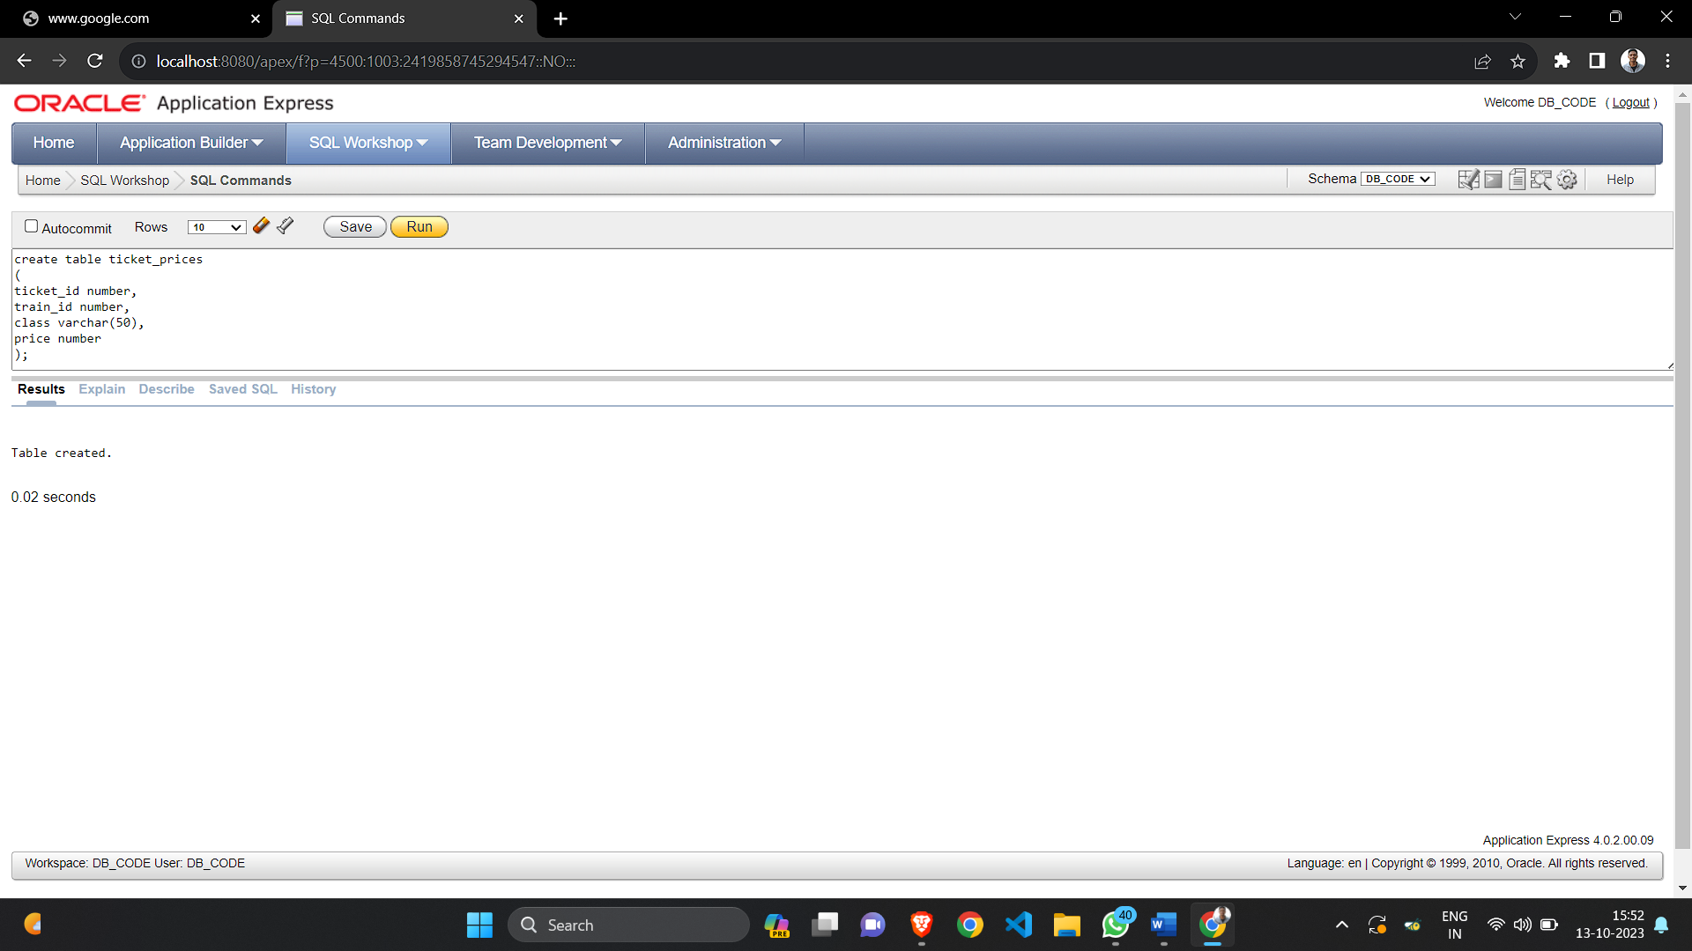

1. **Reservation table created**

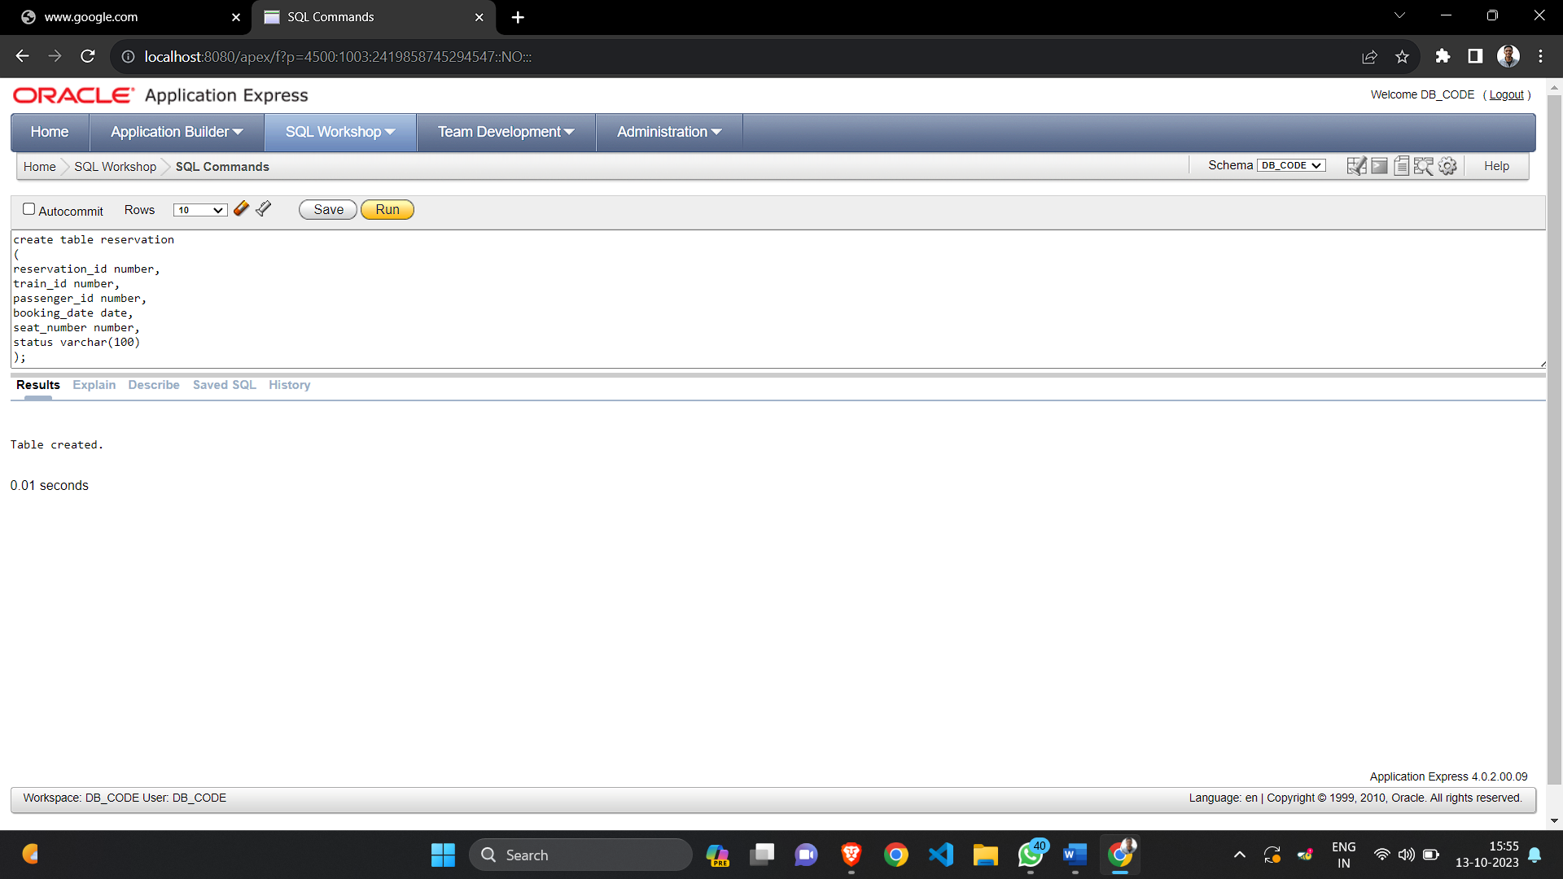

1. **User table created**

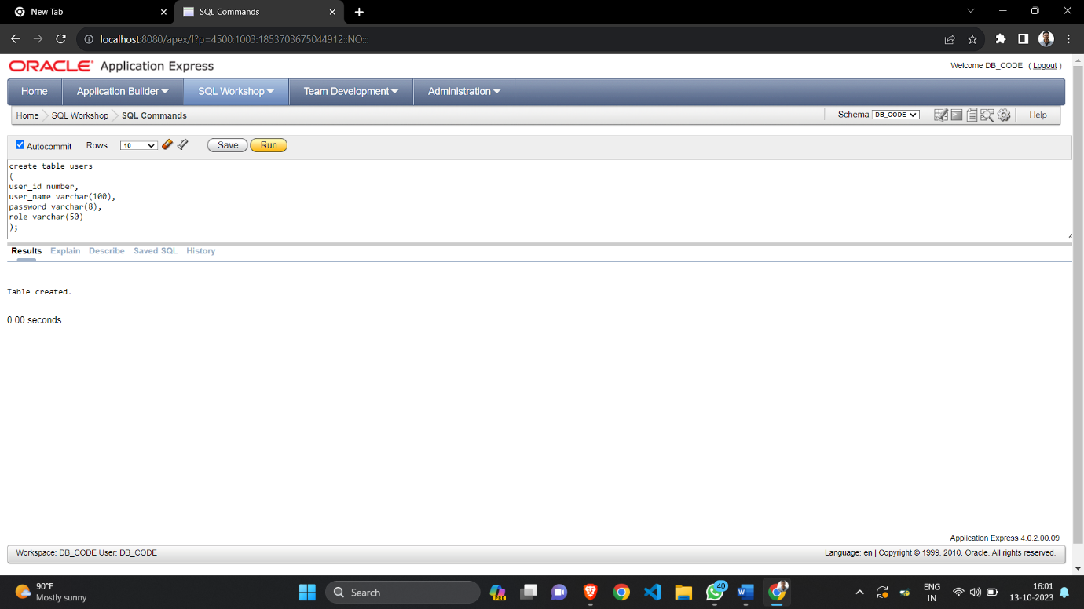

1. **Trains table altered**

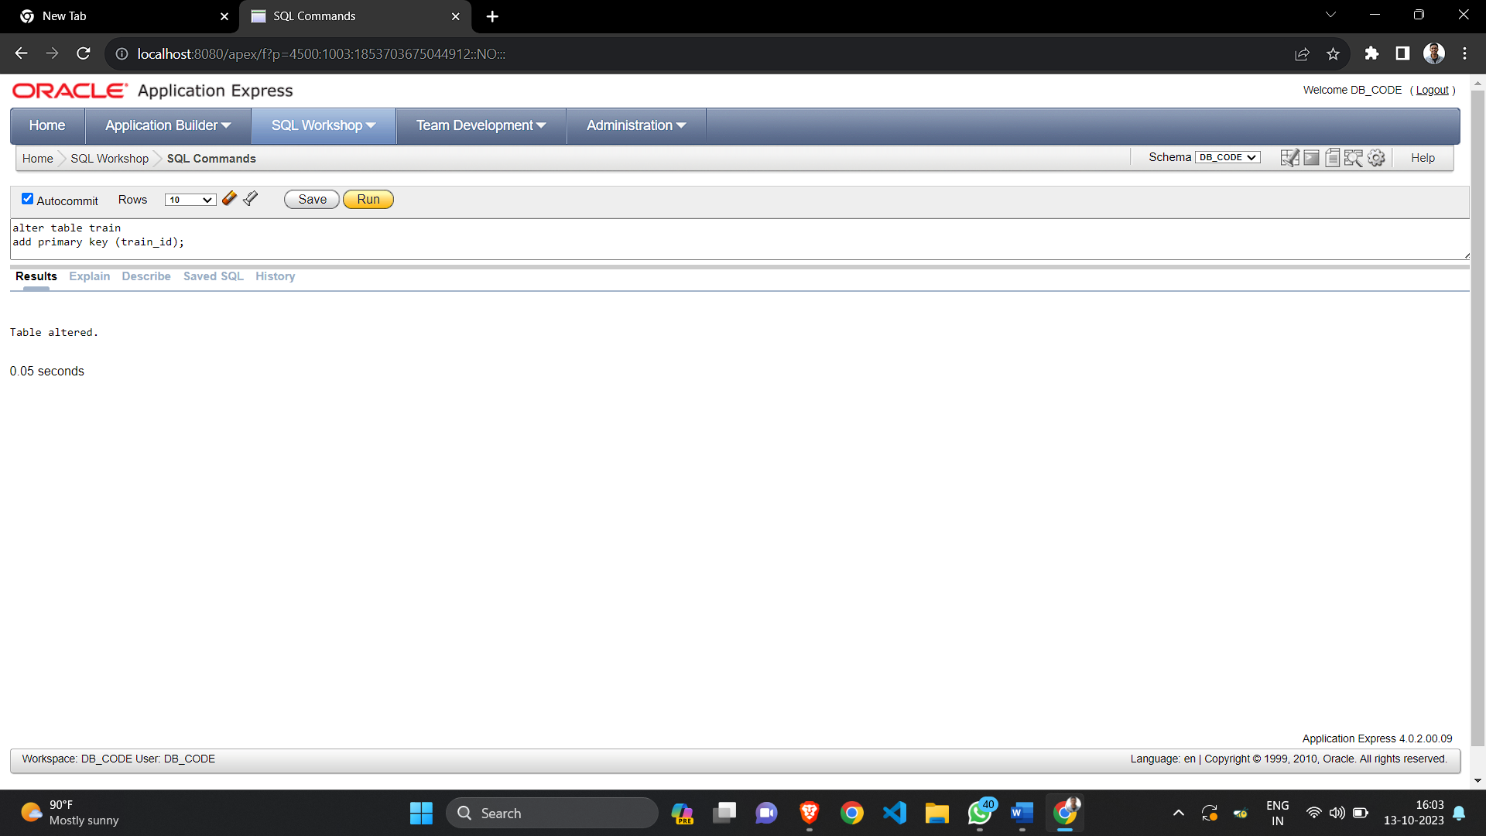

1. **Station table altered**

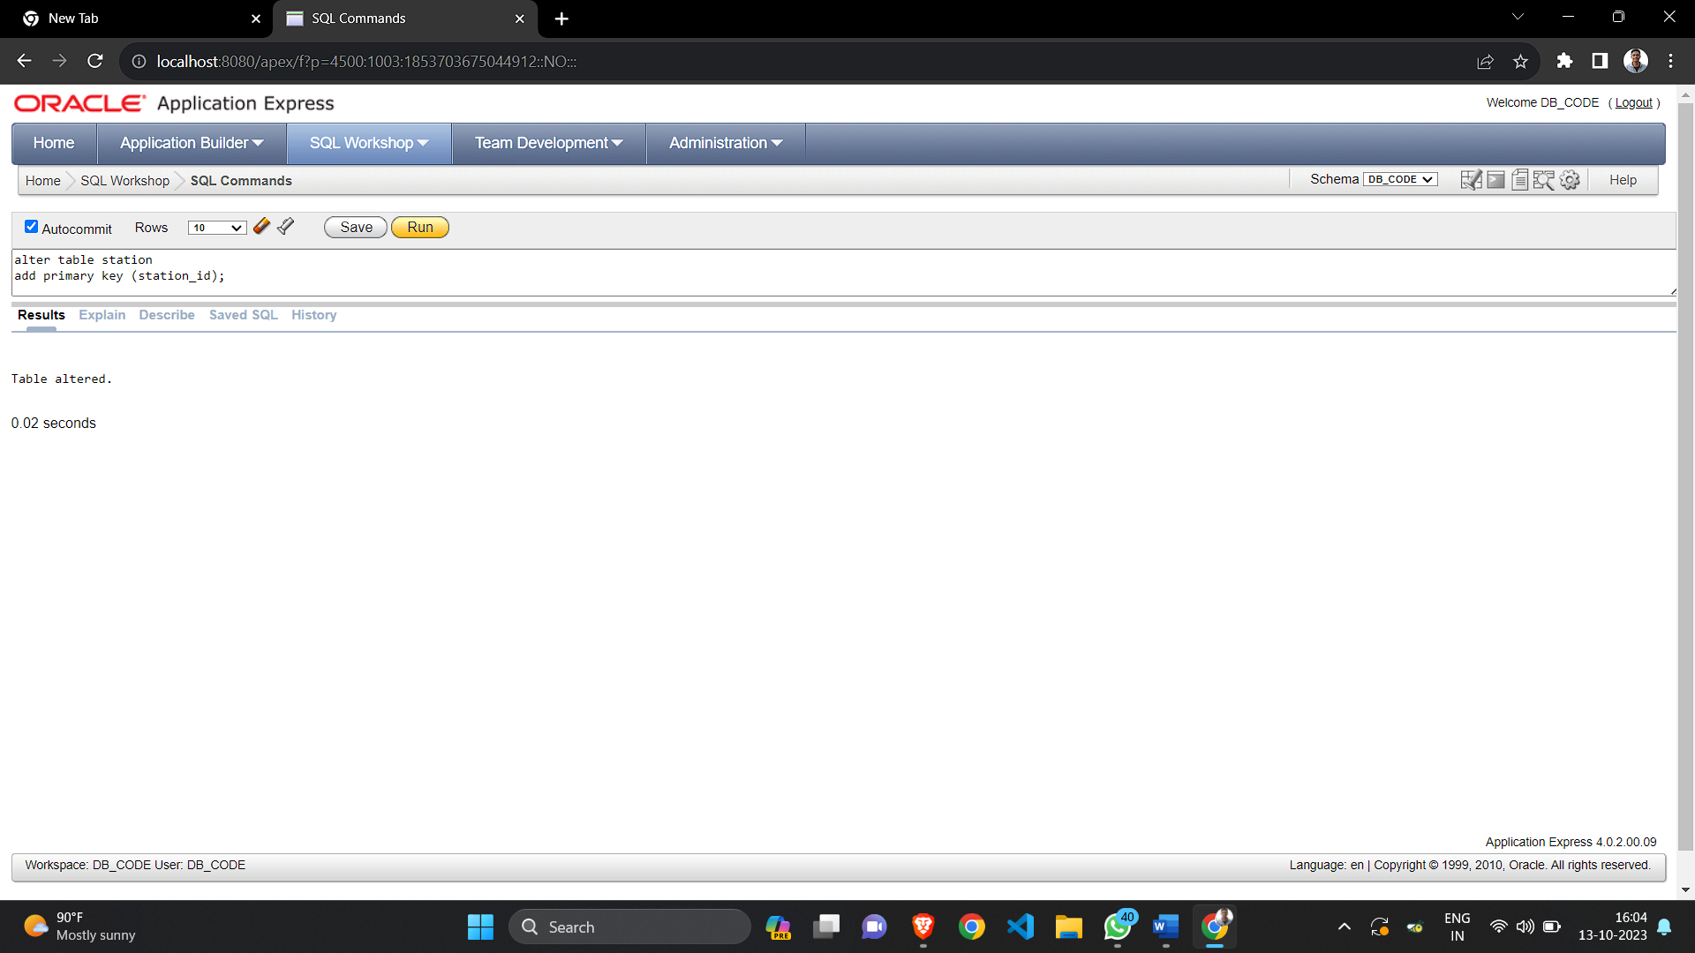

1. **Passenger table altered**

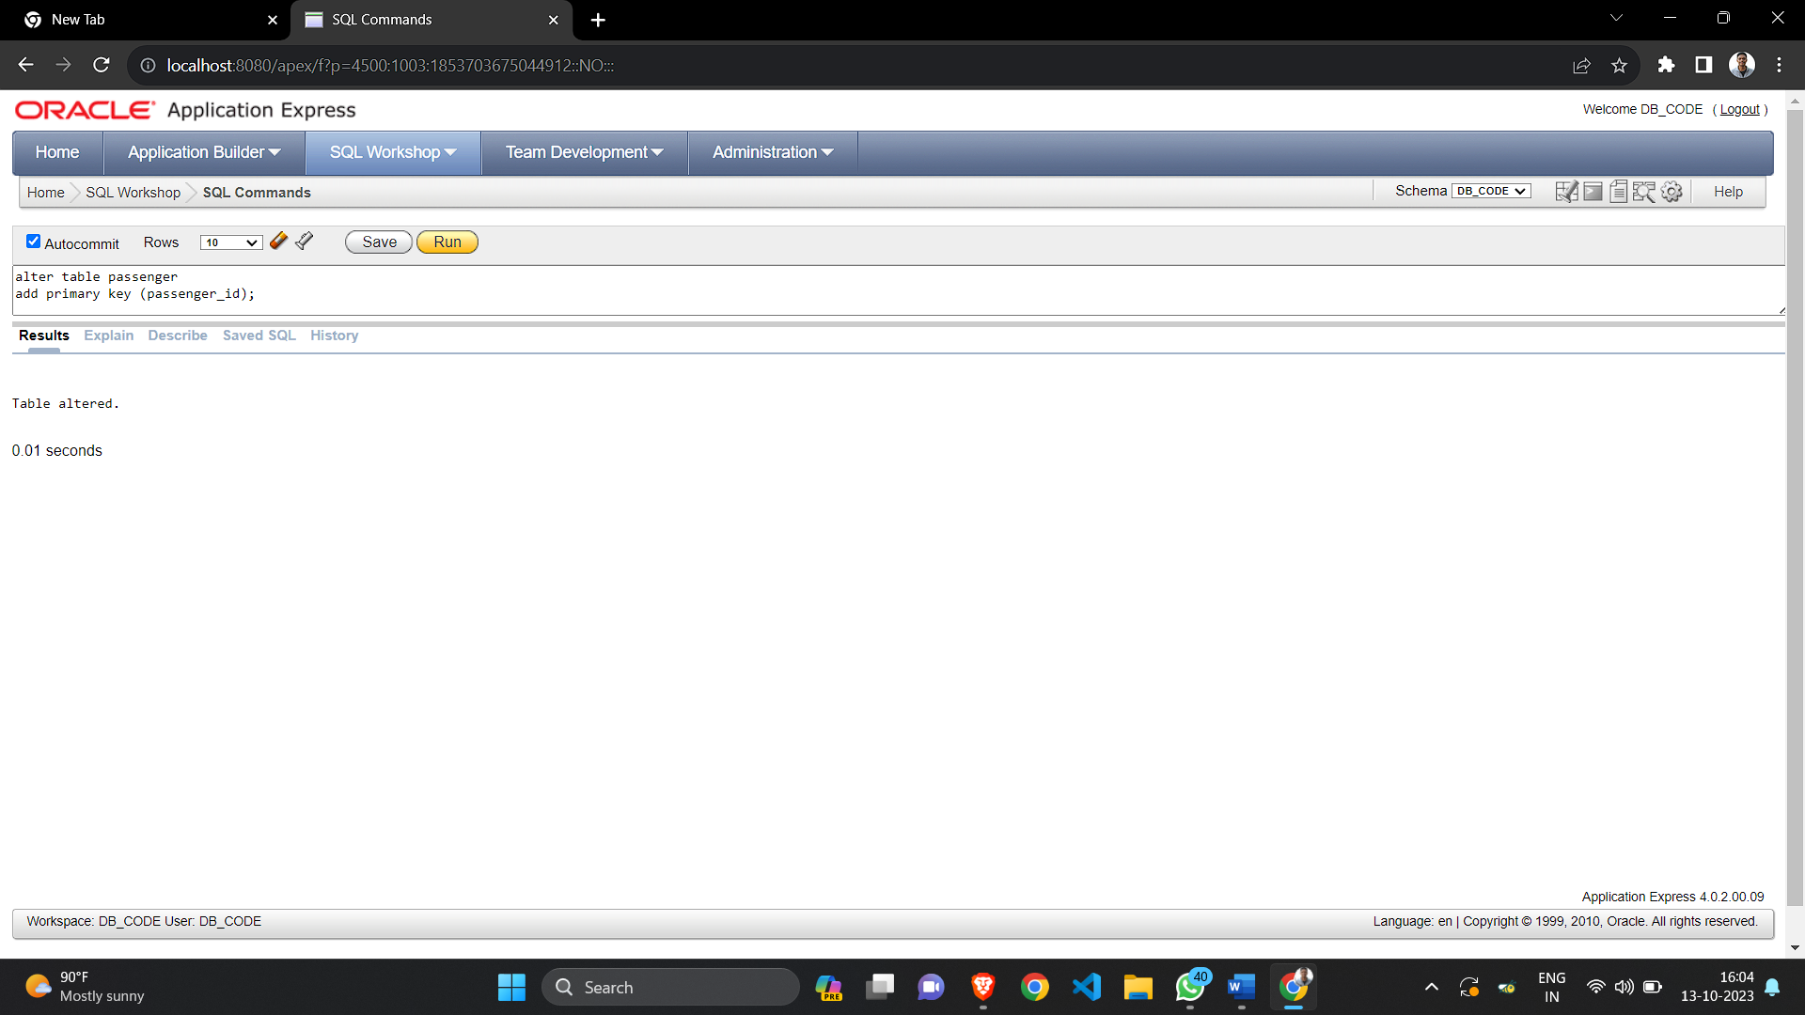

1. **Ticket prices table altered**

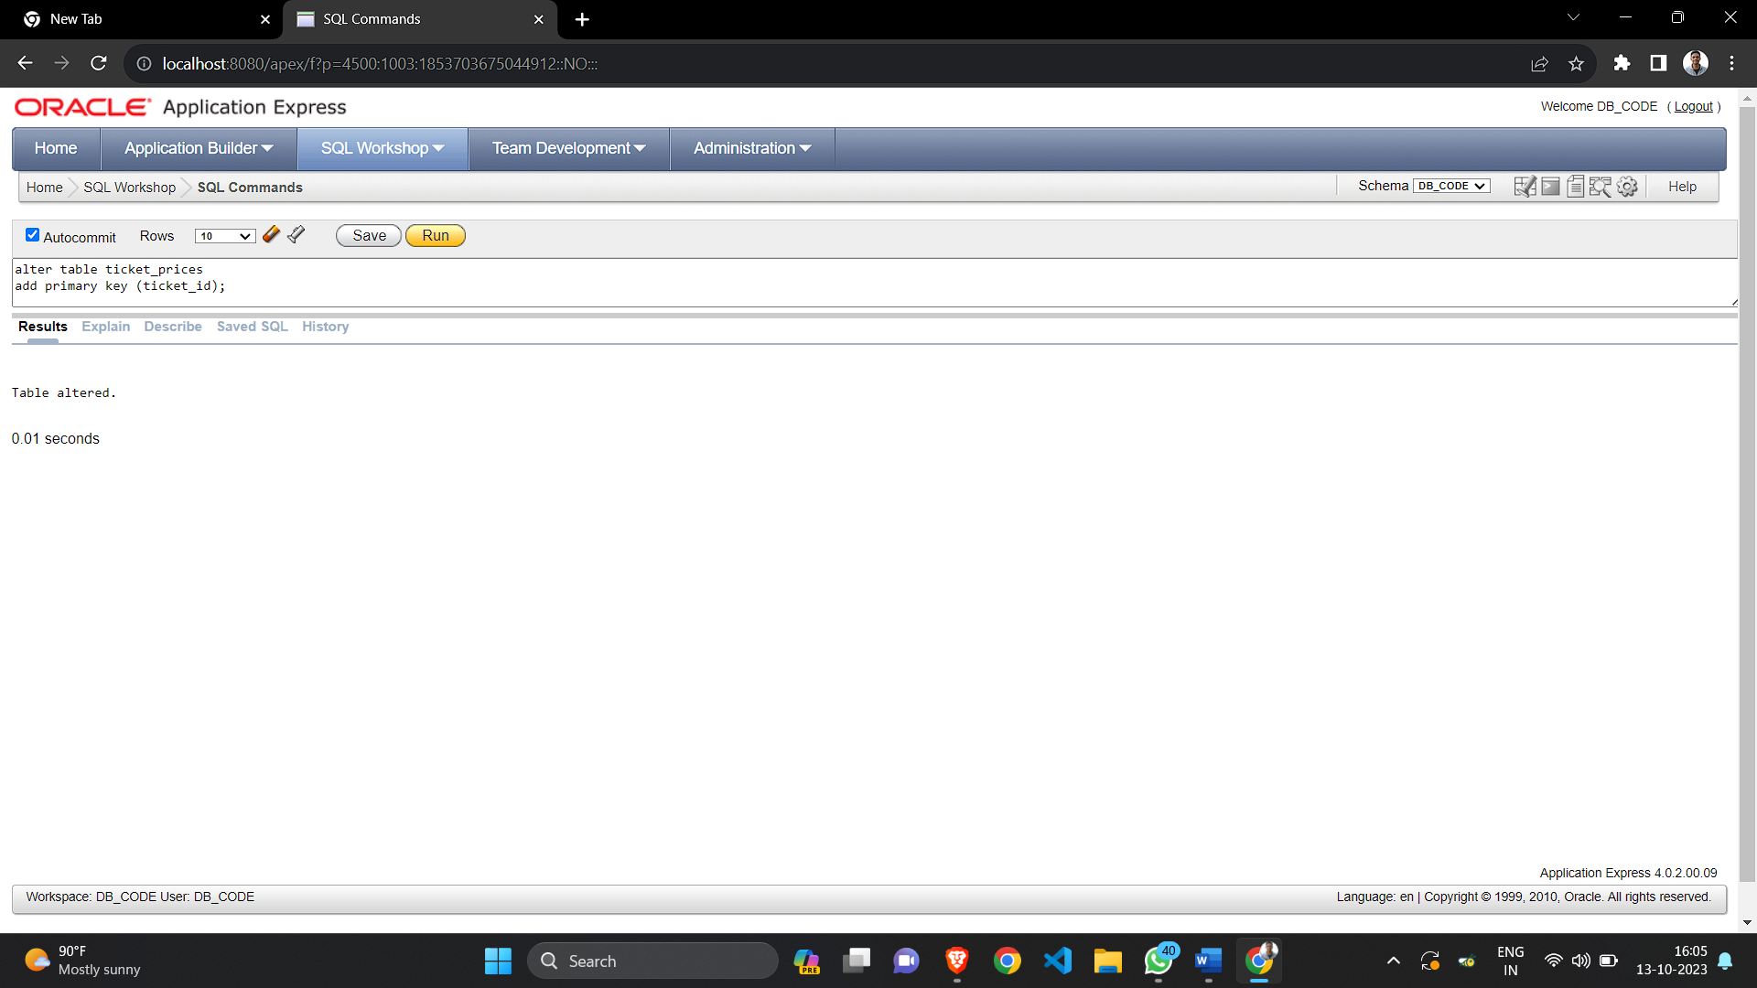

1. **Reservation table altered**

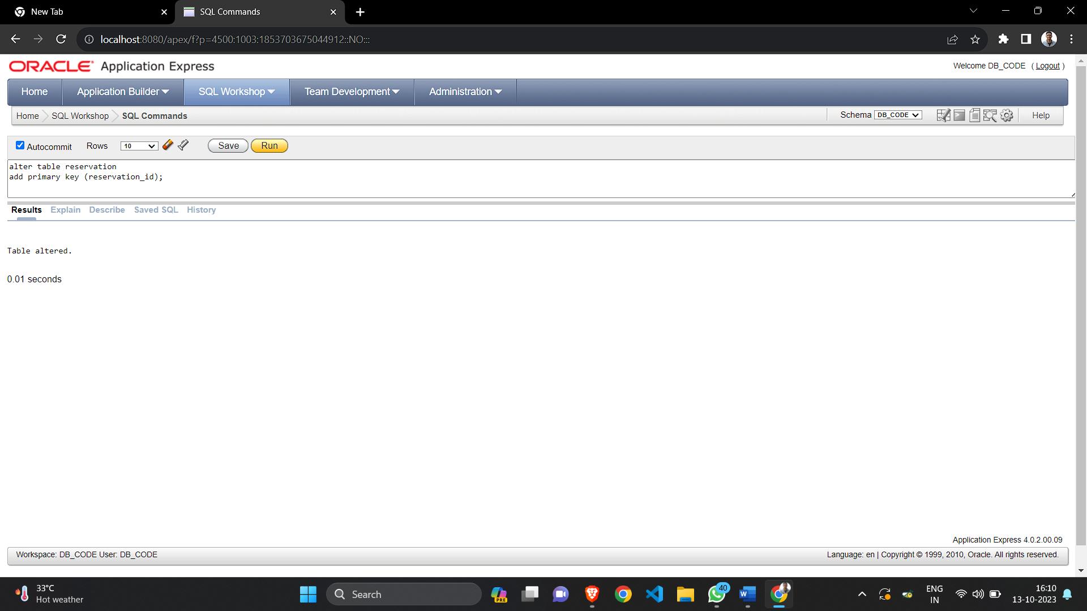

1. **User table altered**

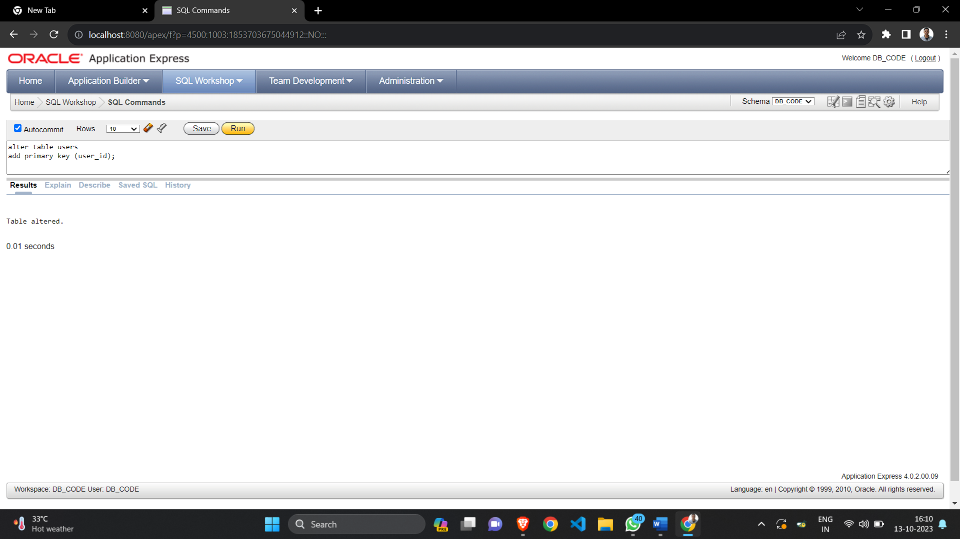

1. **Views in SQL**

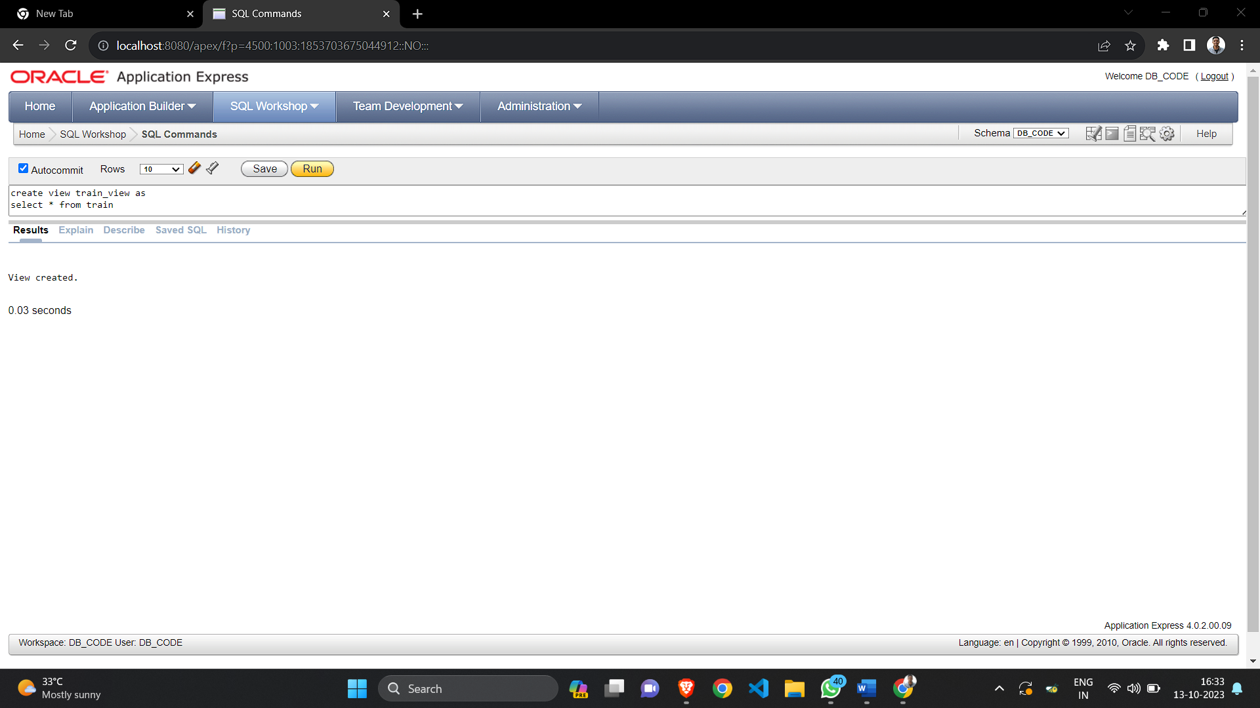

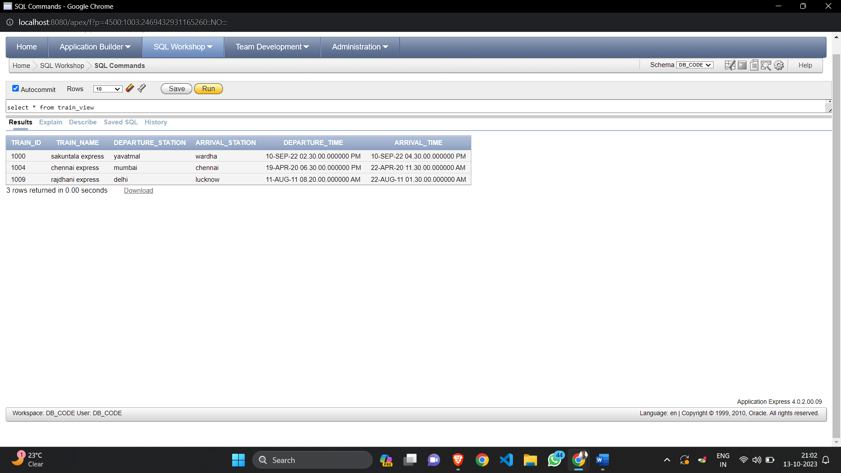

1. **View of 2 tables**

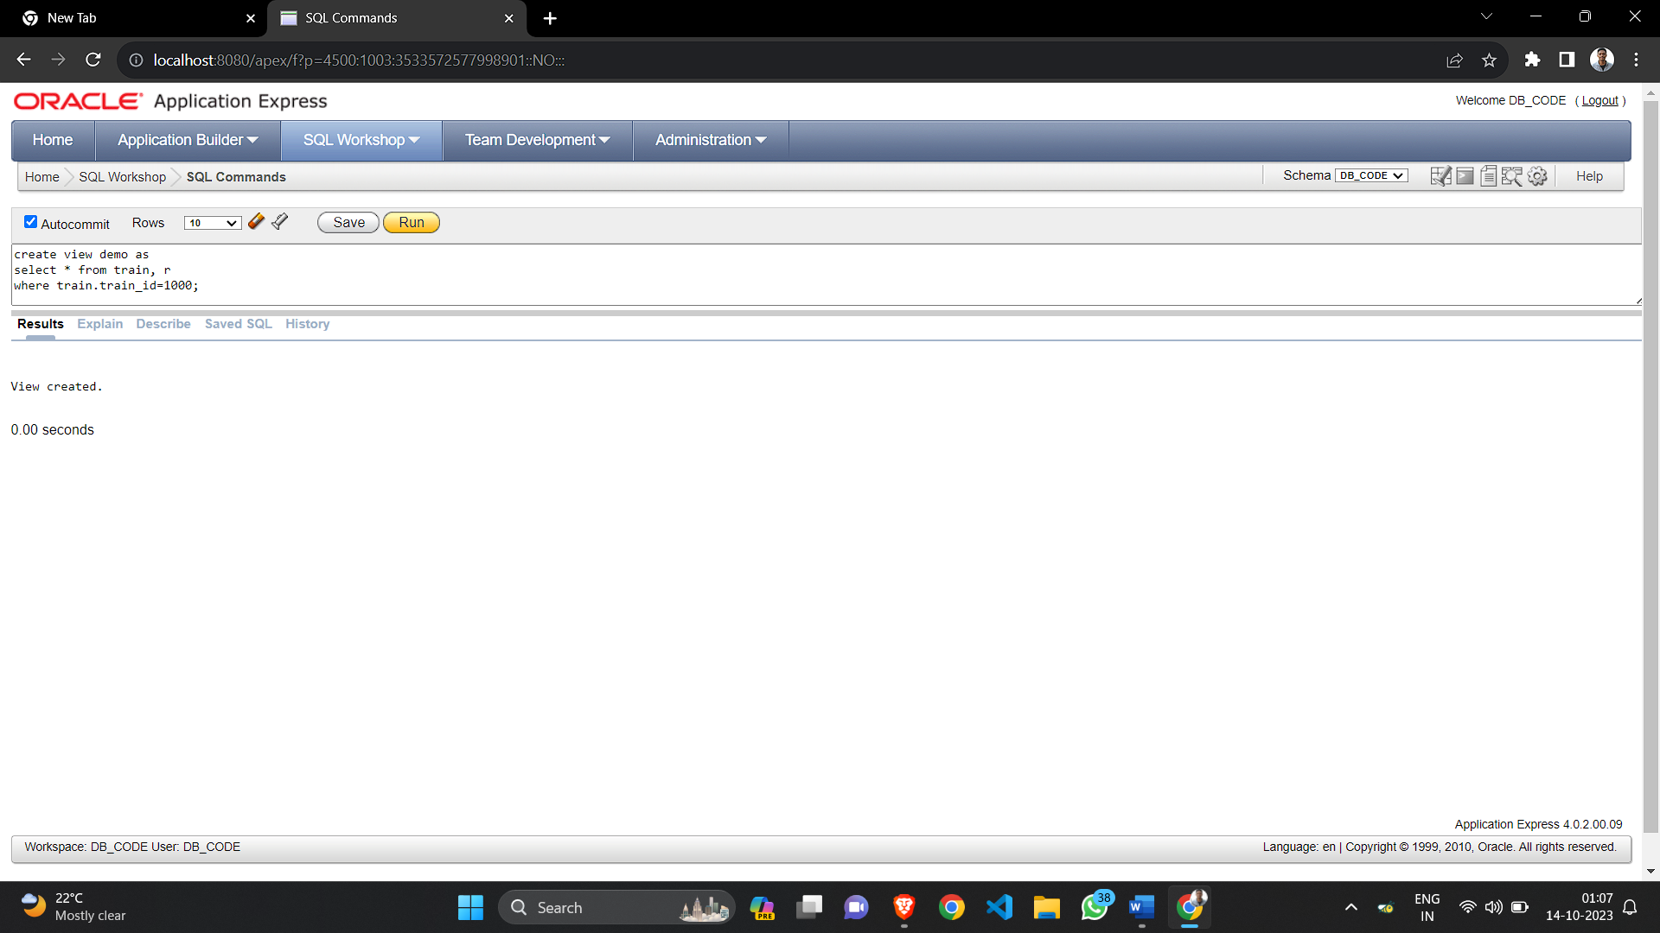

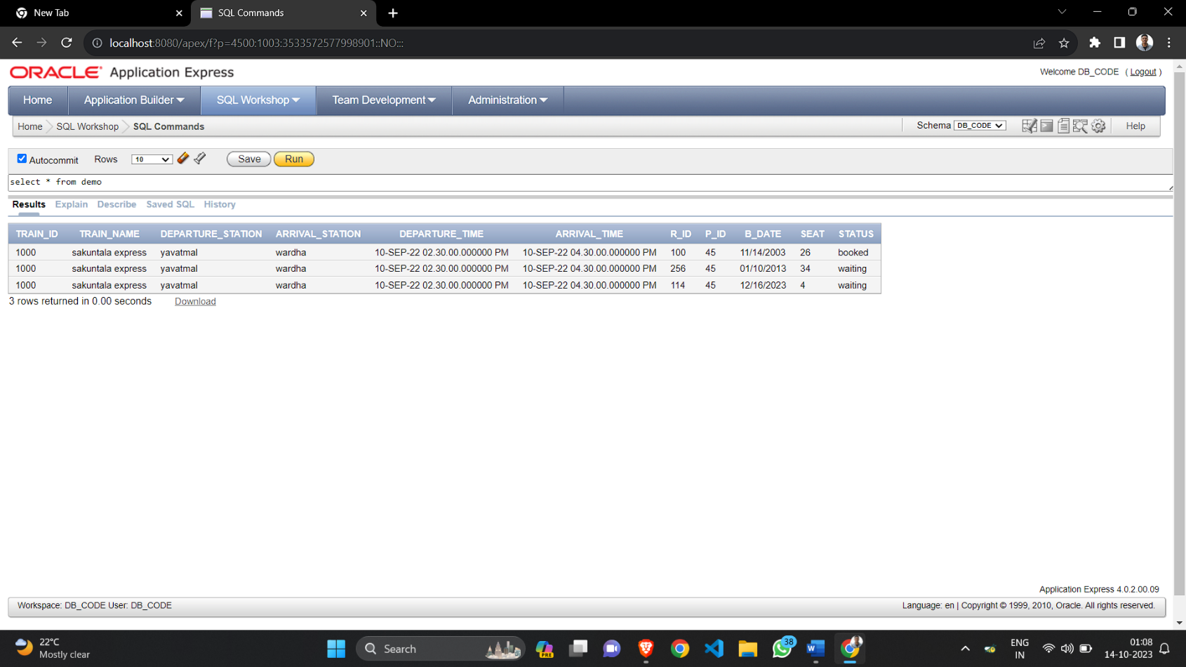

**Assignment 2(b): DML**

1. **Insert into table train**

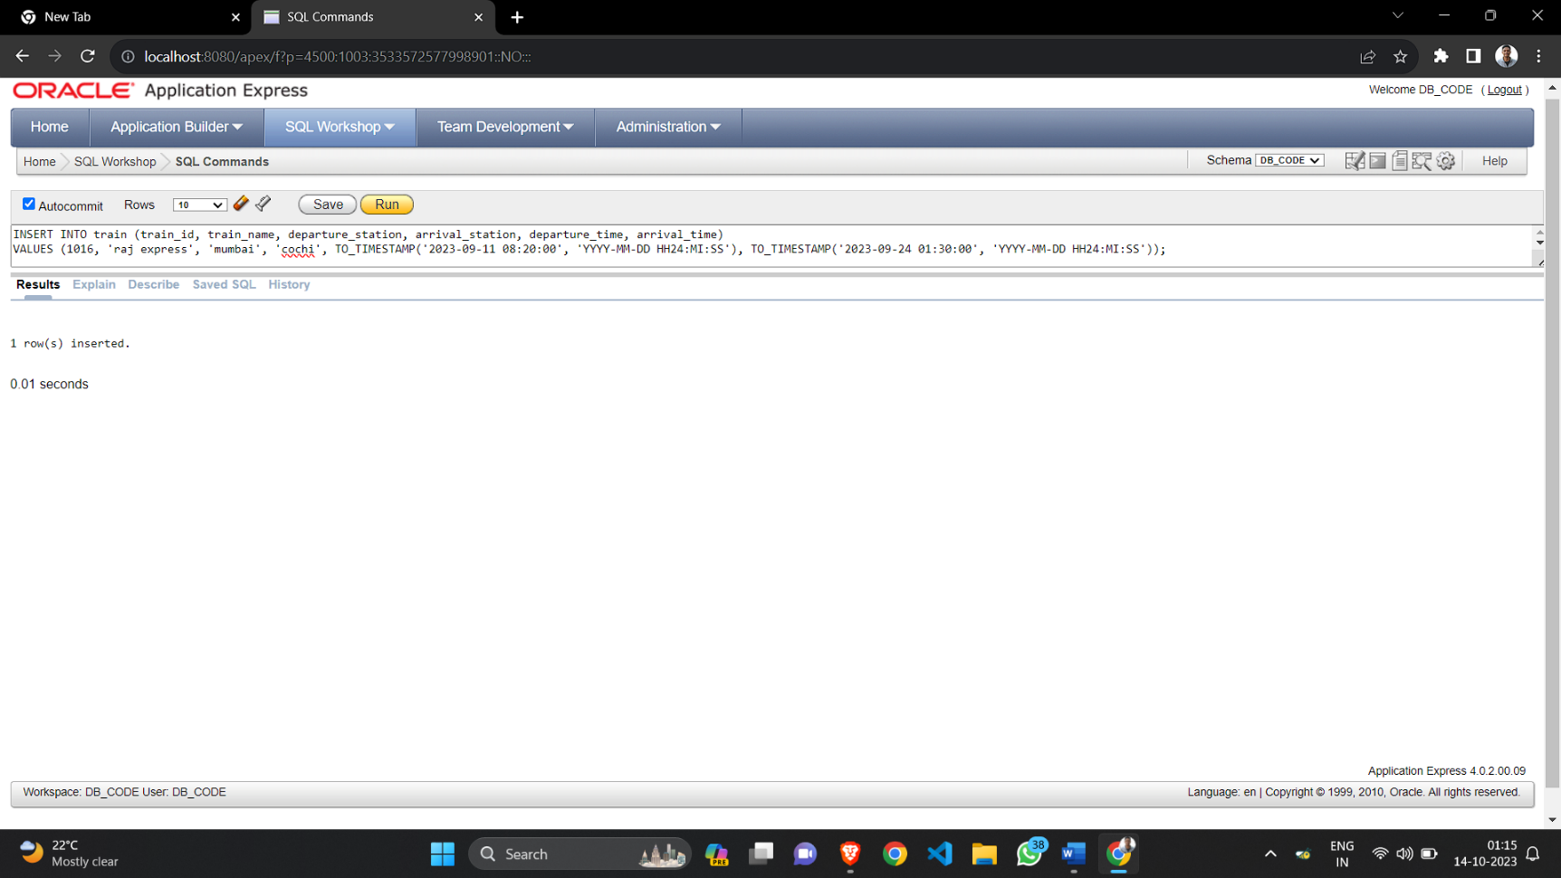

1. **Select from table**

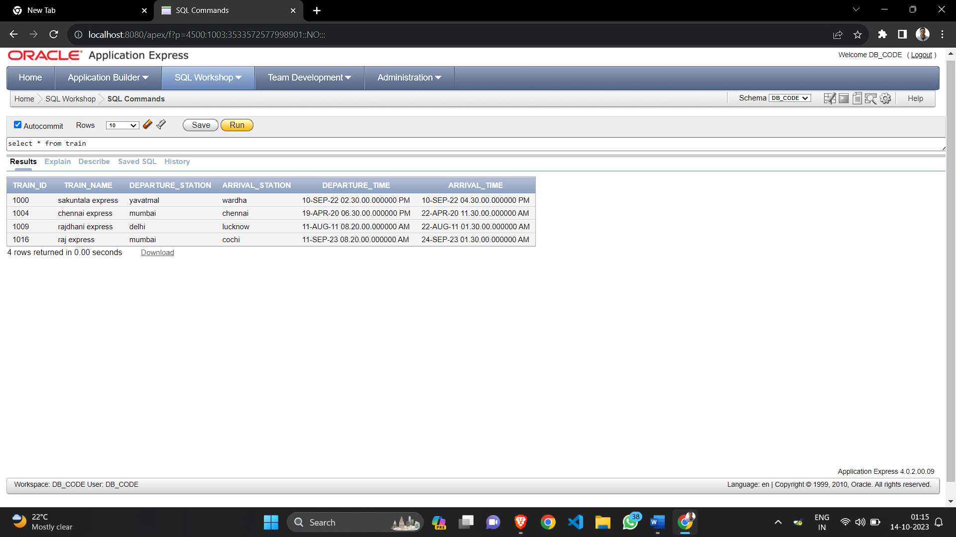

1. **Select where like clause**

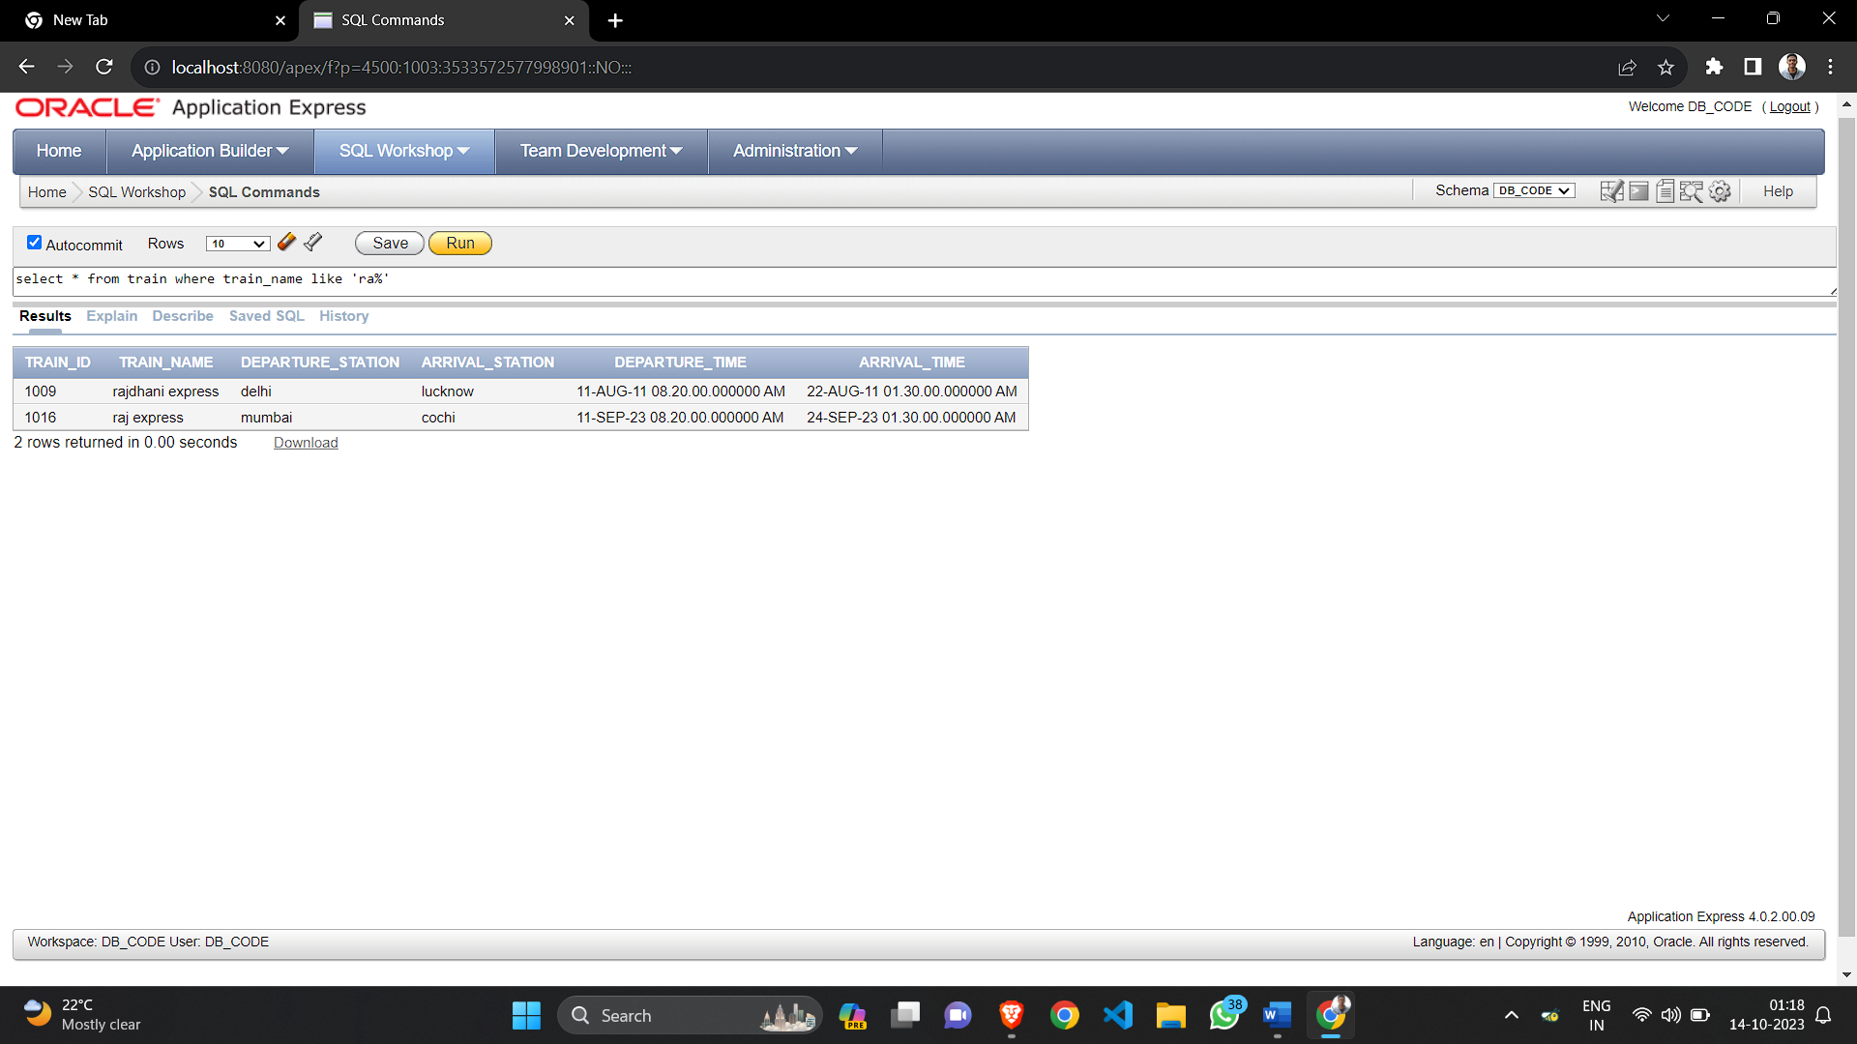

1. **Update**

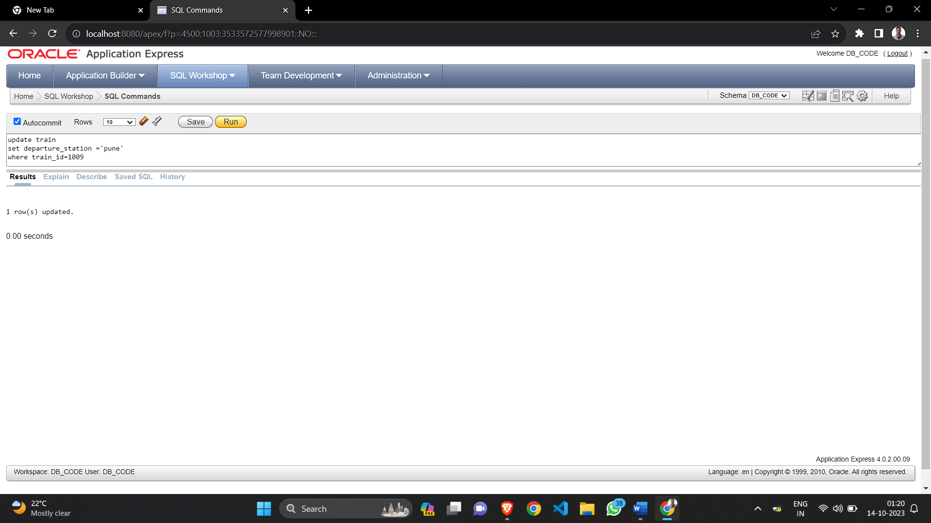

1. **Delete**

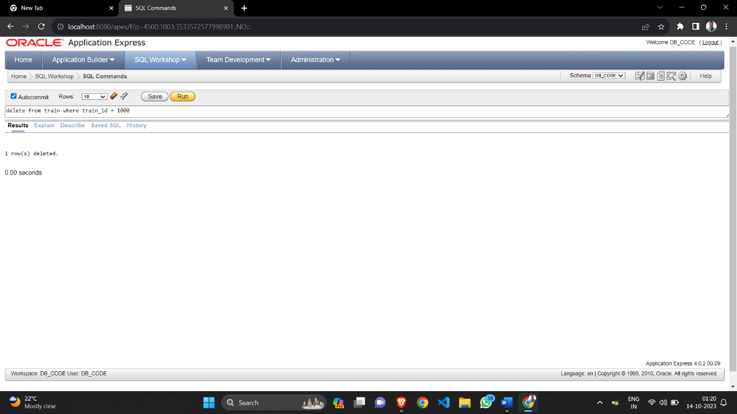

1. **Group by clause**

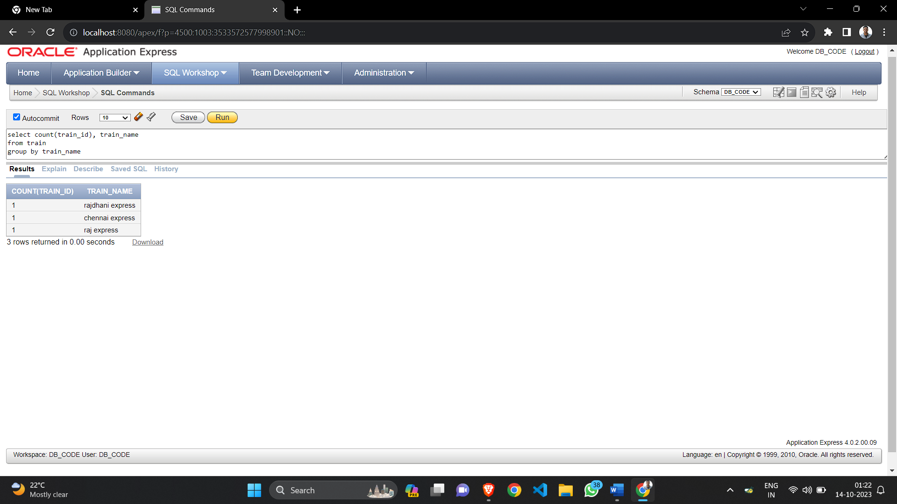

1. **Order by**

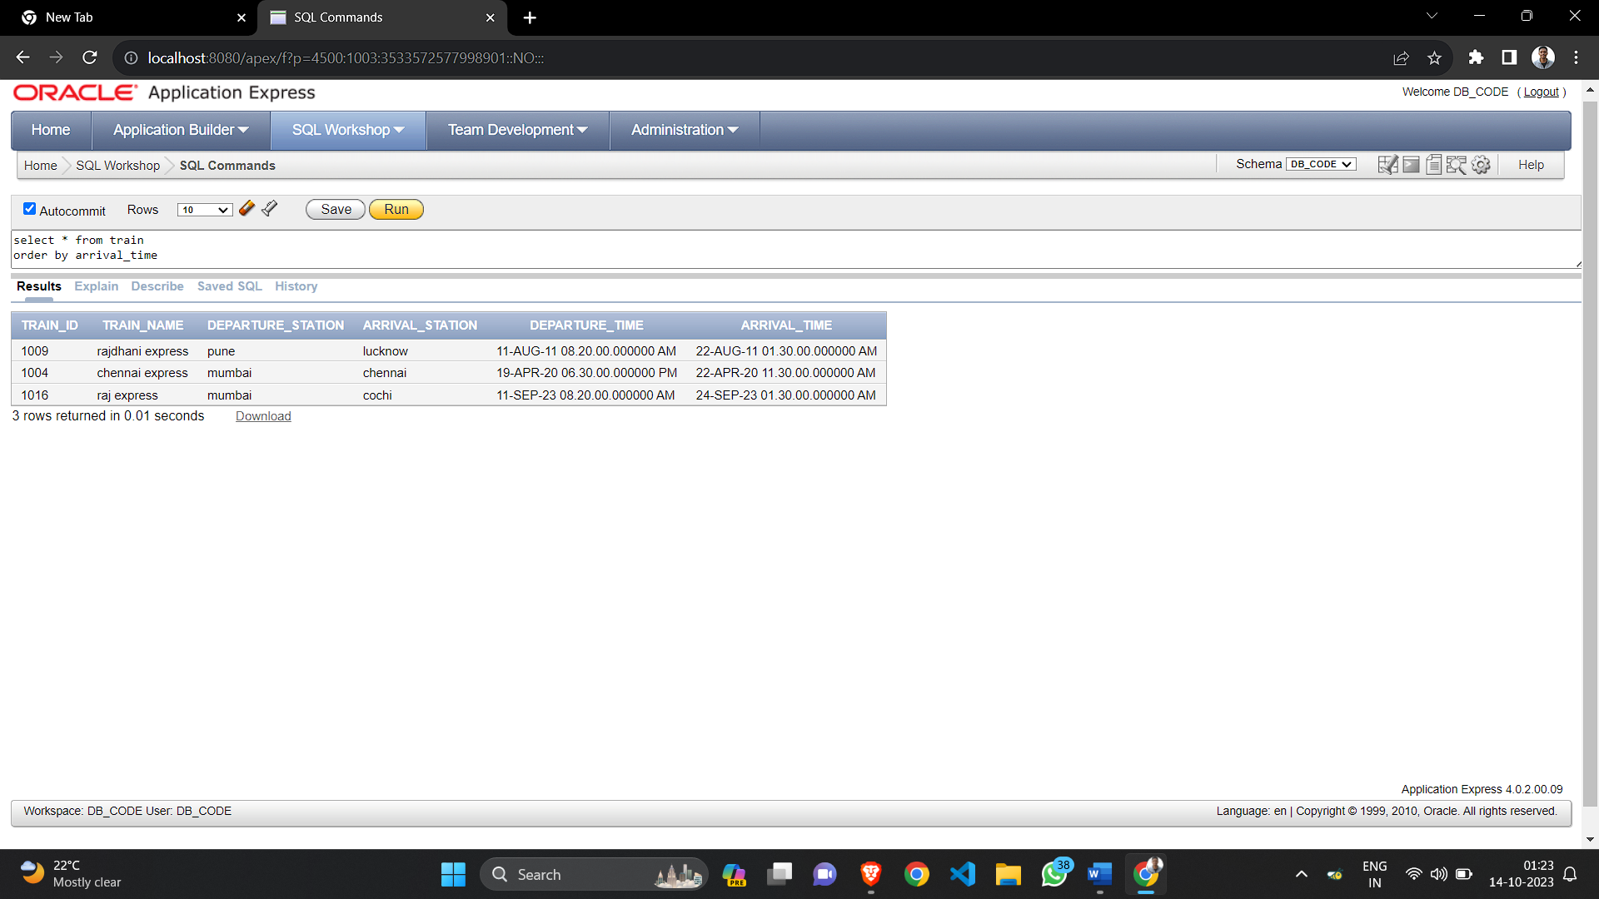

1. **Count**

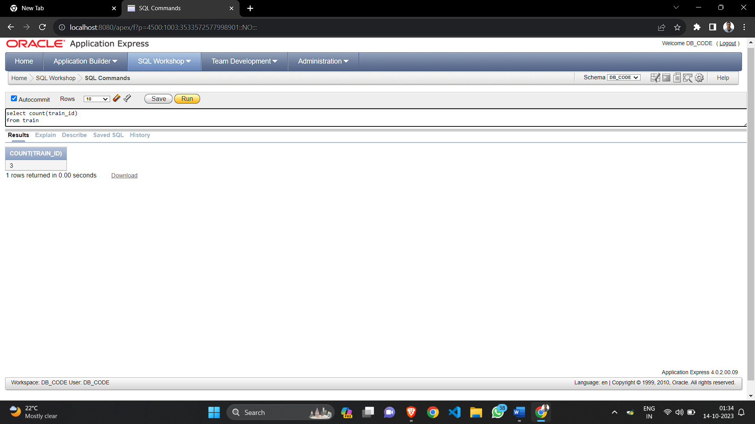

1. **Max**

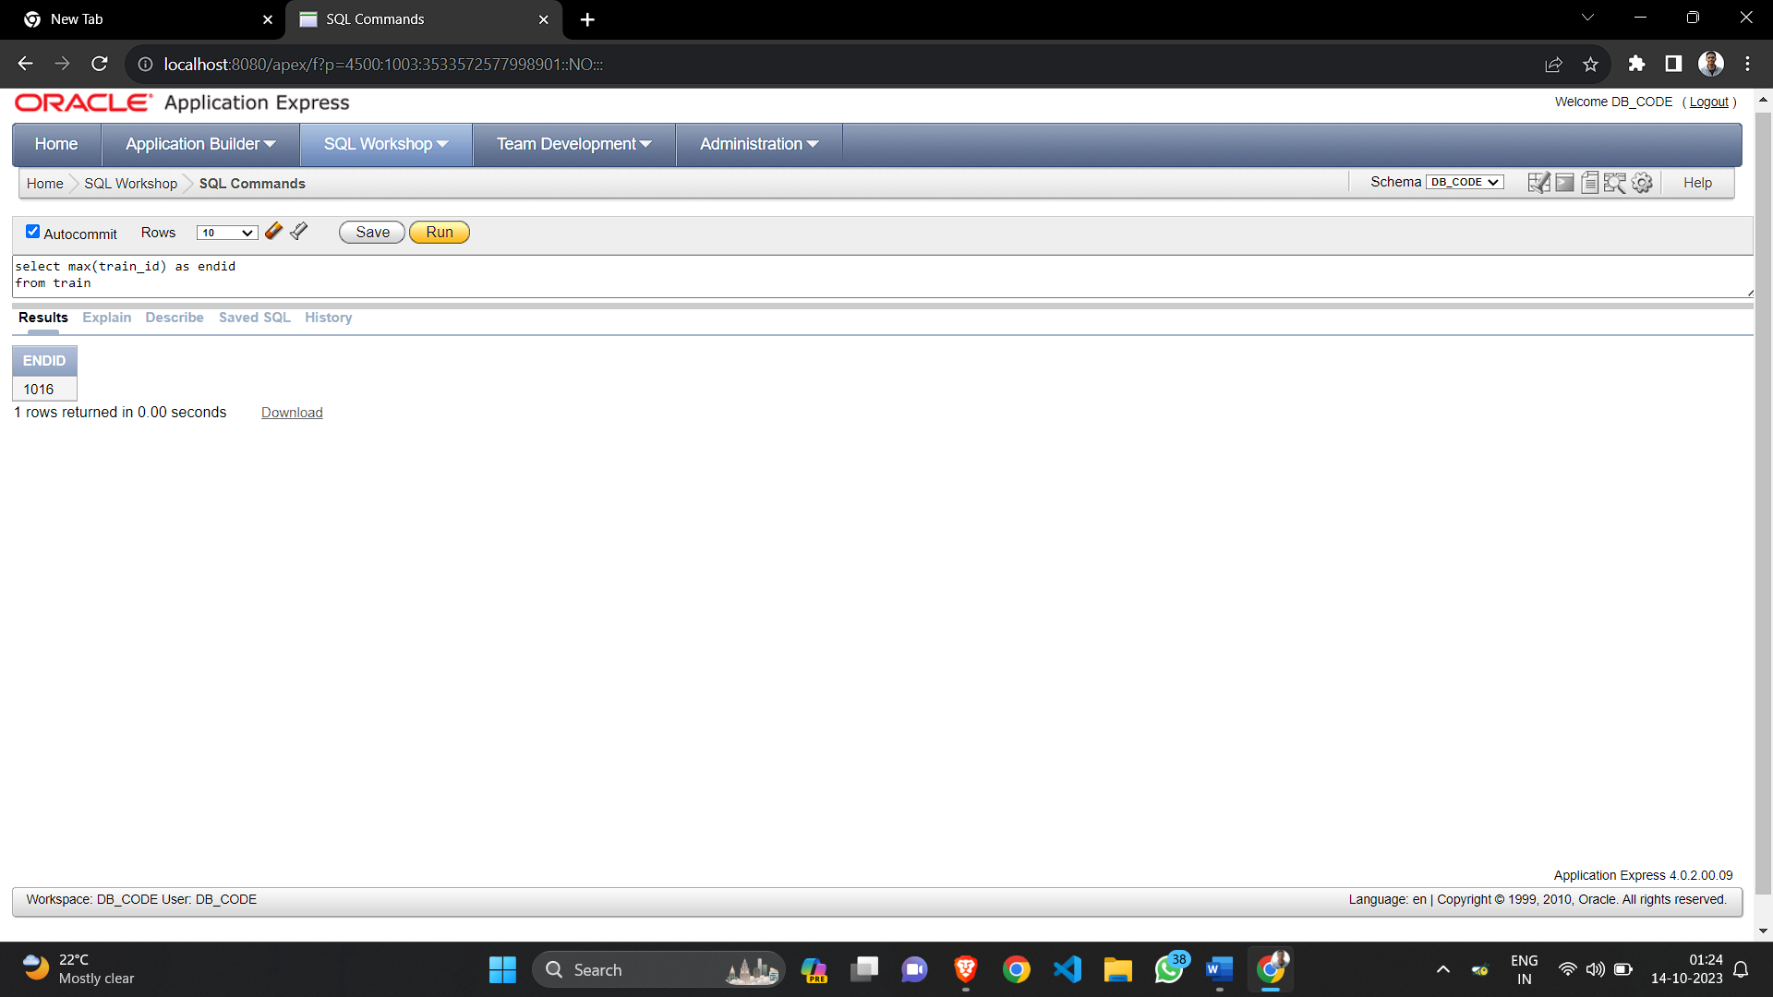

1. **Min**

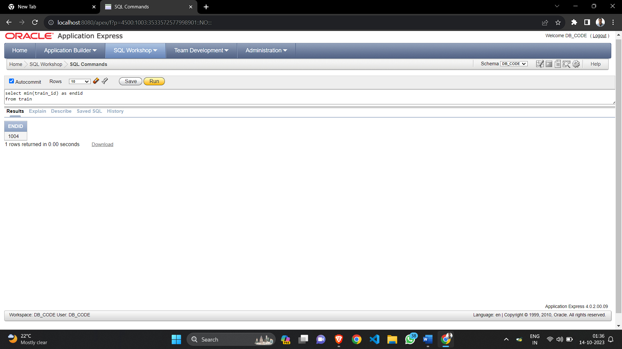

Group A

Assignment Number 9

Database Connectivity

**Problem Statement:**

Write a program to implement MySQL/Oracle database connectivity with any front end language to implement Database navigation operations (add, delete, edit etc.)

**PROGRAM**

//Java program to illustrate Connecting to the Database

import java.sql.*;

public class connect { public static void main(String args[])

{

try

{

Class.forName("oracle.jdbc.driver.OracleDriver");

//Establishing Connection

Connection con= DriverManager.getConnection("jdbc:oracle:thin:@localhost:1521 orcl","login!", "pwd1");

if (con != null)

System.out.println("Connected");

else

System.out.println("Not Connected");

con.close();

}

catch(Exception e)

{

System.out.println(e);

}

}

}

**Implementing Insert Statement**

//Java program to illustrate inserting to the Database

import java.sql.*;

public class insert 1

{

public static void main(String args[])

{ String id = "id";

String pwd="pwd1";

String fullname="geeks for geeks";

String email="geeks@geeks.org";

try

{

Class.forName("oracle.jdbc.driver.OracleDriver");

Connection con- DriverManager.getConnection("jdbc:oracle:thin:@localhost:1521 :orcl", "login1", "pwd1");

Statement stmt = con.createStatement();

//Inserting data in database

String q1 = "insert into userid values("+id+ "," +pwd+ "," +fullname+"", "+email+ "')";

int x = stmt.executeUpdate(q1);

if (x>0)

System.out.println("Successfully Inserted");

Else

System.out.println("Insert Failed")

con.close();

}

catch(Exception e)

{

System.out.println(e);

}

}  
}

**Implementing Update Statement**

// Java program to illustrate updating the Database

import java.sql.*;

public class update1

{

public static void main(String args[])

{

String id="id1";

String pwd="pwd1";

String newPwd="newpwd";

try

{

Class. For Name ("oracle.jdbc. driver. Oracle Driver")

Connection con= DriverManager.getConnection("jdbc:oracle: thin:@localhost: 1521:orcl",

"login1", "pwd1");

Statement stmt = con.createStatement():

//Updating database

String q1="UPDATE userid set pwd="+newPwd+"WHERE id="+id+ " AND pwd="

+ pwd +”” ;

int x=stmt.executeUpdate(q1):

if (x > 0)

System.out.println("Password Successfully Updated");

Else

Sysem.out.println("ERROR OCCURRED:(");

con.close();

}

catch(Exception e)

{

System.out.println(e);

}

}

}

**Implementing Delete Statement**

// Java program to illustrate deleting from Database

import java.sql.*;

public class delete { public static void main(String args[])

{String id="id2"; String pwd="pwd2";

try

{

Class. for Name("oracle .jdbc .driver .Oracle Driver"); Connection con= Driver Manager.get Connection("jdbc: oracle :thin:@localhost:1521:orcl", "login", "pwd1");

Statement stmt = con.createStatement();

// Deleting from database

String q1="DELETE from userid WHERE id="+id+"" AND pwd="" + pwd +""; int x = stmt .execute Update(q1)

if (x > 0)

System.out.println("One User Successfully Deleted");

else

System.out.println("ERROR OCCURRED :(");

con.close();

}

catch(Exception e)

{

System.out.println(e);

}

}

}

**Implementing Select Statement**

// Java program to illustrate selecting from Database

import java.sql.*;

public class select

{

public static void main(String args[])

{

String id="id1"; String pwd="pwd1";

try

{

Class.forName("oracle.jdbc.driver OracleDriver");

Connection con = DriverManager.getConnection(" jdbc:oracle:thin:@localhost: 1521:orcl",

"login1", "pwd1");

Statement stmt= con.createStatement();

**SELECT query**

String q1="select * from userid WHERE id="+id+" AND pwd="+ pwd +" ResultSet rs

stmt.executeQuery(q1);

if (rs.next())

{

System.out.println("User-Id:" + rs.getString(1));

System.out.println("Full Name:" + rs.getString(3));

System.out.println("E-mail :"+rs.getString(4));

}

Else

{ System.out.println("No such user id is already registered");

}

con.close();

}

catch(Exception e)

{ System.out.println(e);

}

}

}

**OUTPUT**

User-id-id1

Full Name - geeks for geeks

E-mail - [geeks@geeks.org](mailto:geeks@geeks.org)

Group B

Assignment Number 1

MongoDB

**Problem Statement:**

Study of Open Source NOSQL Database: MongoDB (Installation, Basic CRUD operations, Execution)

PROGRAM

**Basic CRUD Operation**

• Creating & Inserting Values in new Database

> show dbs

admin 0.000GB

config 0.000GB

local 0.000GB

> use demodb

switched to db demodb

• Showing Database

> show dbs

admin 0.000GB

config 0.000GB

demodb 0.000GB

local 0.000GB

• Drop Database

> use demodb

switched to db demodb

> db.dropDatabase()

{ "dropped": "demodb", "ok": 1}

> show dbs

admin 0.000GB

config 0.000GB

local 0.000GB

• Create Collection MongoDB can create collections automatically also.

> db.createCollection("newCollection")

{ "ok": 1 }

> show collections newCollection

•Drop Collection

> db.newCollection.drop()

True

>show collections

<

• Inserting Document into Collection

db.student.insert({"name":"Sudarshan"})

> WriteResult({ "nInserted": 1 })

> db.student.insert({"name":" Mandar "})

WriteResult({ "nInserted": 1})

• Retriving Document from Collection

> db.student.find()

{"_id": ObjectId("60102acc3e5b451a6eeb4265"), "name": "Sudarshan" }

{"_id": ObjectId("60102ad53e5b451a6eeb4266"), "name": "Mandar" }

// Finding by name

> db.student.find({'name': 'Sudarshan'})

{"_id": ObjectId("6010291c3e5b451a6eeb4264"), "name" : "Sudarshan" }

•Updating Document:

> db.student.update({'name': Mandar '), ($set: {'name': 'Swaraj'}})

WriteResult({ "nMatched": 1, "nUpserted": 8, "nModified" : 1 })

> db.student.find()

{"_id" : ObjectId("60102acc3e5b451a6eeb4265"), "name" : "Sudarshan" }

{“_id” : ObjectId("60102ad53e5b451a6eeb4266"), "name" : "Swaraj" }

• Delete Document:

> db.student.remove({'name': 'Swaraj'})

WriteResult({ "nRemoved" : 1 })

> db.student.find()

{"_id" : ObjectId("60102acc3e5b451a6eeb4265"), "name" : "Sudarshan"}

Group B

Assignment Number 2

MongoDB

**Problem Statement:**

Design and Develop MongoDB Queries using CRUD operations. (Use CRUDoperations, SAVE method, logical operators)

**PROGRAM**

> use

Sudarshan;

switched to do Sudarshan

> db.createCollection('Student');

{ "ok" : 1 }

> db.Student.insert({'Rno":"1", "Name": "Piyush", "Class" : "TE COMP” });

WriteResult({ "nInserted" : 1 })

> db.Student.Insert({"no":"2", "Name": "mohit", 'Class' : 'TE COMP'});

WriteResult({ "nInserted" : 1 }}

> db.Student.Insert({'Rno":"3","Name":"Ashley", "Class' : 'TE COMP’});

WriteResult({ "nInserted": 1 })

> db.Student.insert({'Rno":"4","Name":"Hitesh', 'Class" : "TE COMP'});

WriteResult({ "nInserted": 1 })

> db.Student.Insert({'Rno":"5", "Name": "Pratik", "Class" : "TE COMP”});

WriteResult({ "nInserted" : 1 })

> db.Student.insert({'Rno': '6', 'Name': 'Pratik', 'Class' : 'TE COMP’ });

WriteResult({ "nInserted": 1 })

> db.Student.find();

{"_id": ObjectId("Sbald618f5bbacd4ad81568d"), "Rno": "1",

"Name": "Piyush", "Class": "TE COMP")

{"_id": ObjectId("Sba1d625f5bbacd4ad81568e"), "Rno": "2",

"Name": "nohit", "Class": "TE COMP" }

{"_id": ObjectId("5ba1d63af5bbacd4ad81568f"), "Rno":"3",

"Name": "Ashley", "Class": "TE COMP" }

{"_id": ObjectId("5ba1d647f5bbacd4ad815698"), "no" : "4",

"Name": "Hitesh", "Class": "TE COMP" }

{"_id": ObjectId("5ba1d65ef5bbacd4ad815691"), "Rno": "5",

"Name": "Pratik", "Class": "TE COMP" } {"id":

ObjectId("Sba1d56df5bbacd4ad815692"), "Rno" : "6",

"Name": "Pratik", "Class": "TE COMP" }

> db.Student.find().pretty();

{

"id": ObjectId("Sbald618f5bbacd4ad81568d"),

"Rno" : "1",

"Name" : "Piyush",

"Class" : "TE COMP”

}

{

"id": ObjectId("5ba1d625f5bbacd4ad81568e"),

"Rno": "2", "Name": "mohit",

"Class": "TE COMP"

}

{

"_id": ObjectId("5ba1d63af5bbacd4ad81568f"),

"Rno" : "3",

"Name": "Ashley",

"Class": "TE COMP”

}

{

“_id": ObjectId("5ba1d647f5bbacd4ad815690"),

"Rno" : "4",

"Name": "Hitesh",

"Class": "TE COMP"

}

{

"id": ObjectId("5ba1d65ef5bbacd4ad815691"),

"Rno": "5",

"Name": "Pratik",

"Class": "TE COMP"

}

{

"id": ObjectId("5ba1d66df5bbacd4ad815692"),

"Rno": "6",

"Name": "Pratik"

"Class": "TE COMP

}

> db.Student.update({'Name': 'Hitesh'}, {$set:

{'Name': 'Henry'}});

WriteResult({ "nMatched": 1, "nupserted": 8, "nModified" : 1 })

> db.Student.find().pretty(); { "_id": ObjectId("5b8fad4ef80832a0a58b5036"),

"Rno" : "1",

"Name": "Piyush",

"Class": "TE COMP”

}

{

"id": ObjectId("5b8fad62fe8832aea5eb5037"),

"Rno": "2",

"Name": "mohit",

"Class": "TE COMP”

}

{

"id": ObjectId("5b8fad70fe0832a0a5065038").

"Rno" : "3",

"Name": "Ashley",

"Class": "TE COMP”

}

{

"id": ObjectId("5b8fad7ff00832a0a5055039"),

"Rno": "4",

"Name": "Henry",

"Class": "TE COMP"

}

{

"id": ObjectId("5b8fad8df00832a0a506503a"),

"Rno": "5",

"Name": "Pratik",

"Class": "TE COMP"

}

{

"id": ObjectId("5b8fada4f00832a0a58b583b"),

"Rno" : "6",

"Name": "Pratik",

"Class": "TE COMP"

}

{

> db.Student.remove({"ADD":"MP"));

WriteResult({ "nRemoved": 1 }){

> db. Student.find().pretty();

"_id" : ObjectId("5b8fad62f08832a0a5065837"),

"Rno": "2",

"Name": "mohit",

"Class": "TE COMP”

}

{

"_id": ObjectId("5b8fad70f08832a0a58b5038"),

"Rno":"3",

"Name": "Ashley",

"Class": "TE COMP”

}

{

"id": ObjectId("5b8fad7ff0e832a0a50b5039"),

"Rno": "4",

"Name": "Henry",

"Class": "TE COMPT

}

{

"_id": ObjectId("5b8fad8df00832a0a506503a"),

"Rno" : "5",

"Name": "Pratik",

"Class": "TE COMP"

}

{

"_id": ObjectId("Sb8fada4f00832a0a58b503b"),

"Rno" : "6",

"Name": "Pratik",

"Class": "TE COMP"

}

>db.Student.save((_id:ObjectId("5b8fad4ef00832a8a58b5036"), "RNO ":"1","NAME":"PIYUSH", "CLASS":"TE COMP","ADD":"MP"});

WriteResult({ "nMatched": 1, "nUpserted": 0, "nModified" : 1 })

> db.Student.find().pretty();

{

"id": ObjectId("5b8fad4efe8832a0a5065036"),

"RNO" : "1",

"NAME": "PIYUSH",

"CLASS": "TE COMP",

"ADD": "MP"

}

{

"_id" : ObjectId("5b8fad62f08832a0a58b5037"),

"Rno" : "2",

"Name": "mohit",

"Class": "TE COMP™

}

"_id": ObjectId("5b8fad70f00832a8a5eb5838"),

"Rno":"3",

"Name": "Ashley",

"Class": "TE COMP"

}

{

"id": ObjectId("5b8fad7ff80832a0a58b5039"),

"Rno": "4",

"Name": "Henry",

"Class": "TE COMP"

}

{

id": ObjectId("5b8fad8df00832a0a5eb583a"),

"no" : "5",

"Name": "Pratik",

"Class": "TE COMP

}

{

"id": ObjectId("5b8fada4f00832aea50b5836"),

"no":"6",

"Name": "Pratik",

"Class": "TE COMP

}

> db.Student.find((Sand: [{"Name":"Piyush"},{"no":"2"}]});

> db.Student.Find((Sand: [{"Name":"Plyush"),

{"Rno":"1"}]}).pretty();

{

"_id" : ObjectId("5ba1d61845bbacd4a81568d"),

"Rno" : "1",

"Name": "Piyush",

"Class": "TE COMP”

}

> db.Student.find((Sand: [{"Name":"Piyush"),

{"Rno":"2"}]}).pretty();

> db.Student.find((Sor:[{"Name":"Piyush"),

{"Rno":"2"}]}).pretty();

{

"_id": ObjectId("5ba1d618f5bbacd4ad81568d"),

"Rno":"1",

"Name": "Piyush",

"Class": "TE COMP

}

{

"_id": ObjectId("5ba1d625f5bbacd4ad81568e"),

"Rno" : "2",

"Name": "mohit",

"Class": "TE COMP”

}

> db.Student.find({$or:[{"Name":"Piyush"},{"Class":"TE COMP"}]}).pretty();

{

"_id": ObjectId("5ba1d618f5bbacd4ad81568d"),

"Rno": "1",

"Name": "Piyush",

"Class": "TE COMP"

}

{

"id": ObjectId("5ba1d625f5bbacd4ad81568e"),

"Rno" : "2",

"Name": "mohit",

"Class": "TE COMP”

}

{

id": ObjectId("Sba1d63af5bbacd4a81568"),

"Rno" : "3",

"Name": "Ashley",

"class":"TE COMP”

}

{

"_id": ObjectId("5ba1d647f5bbacd4ad815690"),

"Rno":"4",

"Name": "Hitesh",

"Class": "TE COMP"

}

{

"_id": ObjectId("5ba1d65ef5bbacd4ad815691"),

"Rno": "5",

"Name": "Pratik", "Class": "TE COMP

}

{

"id": ObjectId("5ba1d66df5bbacd4ad815692"),

"Rno" : "6",

"Name": "Pratik",

"Class": "TE COMP"

}

> db.Student.find(($or:[{"Name":"Piyush"},{"Class":"TE COMP"}]}).pretty();

> db.Student.find(($or:[{"Name":"Piyush"},

{"Rno":"2"}]}).pretty();

{

"_id": ObjectId("5ba1d63af5bbacd4ad81568f"),

"Rno": "3",

"Name": "Ashley",

"Class": "TE COMP"

}

{

"_id": ObjectId("5ba1d647f5bbacd4ad815690"),

"Rno" : "4",

"Name": "Hitesh",

"Class": "TE COMP"

}

{

"id": ObjectId("5ba1d65ef5bbacd4ad815691"), "Rno": "5",

"Name": "Pratik",

"Class": "TE COMP"

}

{

-_id" : ObjectId("5ba1d66df5bbacd4d815692"),

"Name": "Pratik",

"Rno" : "6",

"Class": "TE COMP

}

db.Student.find(("Rno": (Snot: ($1t:"3"}}}).pretty();

{

"_id" : ObjectId("5ba1d63af5bbacd4ad81568f"),

"Rno": "3",

"Name": "Ashley", "Class": "TE COMP

}

{

"_id" : ObjectId("5ba1d647f5bbacd4ad815690"),

"Rno" : "4",

"Name": "Hitesh",

"Class": "TE COMP"

}

{

"_id": ObjectId("Sba1d65ef5bbacd4ad815691"),

"Rno": "5",

"Name": "Pratik",

"Class":"TE COMP"

}

{

"_id": ObjectId("5ba1d66df5bbacd4ad815692"),

"Rno": "6", "Name": "Pratik",

"Class": "TE COMP"

}

> db.Student.find({"Rno": { $eq:"5"}}).pretty();

{

"id": ObjectId("Sba1d65ef5bbacd4ad815691"),

"Rno": "5",

"Name": "Pratik",

"Class": "TE COMP"

}

> db.Student.find({"Rno": { $ne:"5"}}).pretty();

{

"_id": ObjectId("5ba1d618f5bbacd4ad81568d"),

"Rno" : "1",

"Name": "Piyush",

"Class": "TE COMP"

}

{

"id": ObjectId("5ba1d625f5bbacd4ad81568e"),

"Rno" : "2",

"Name": "mohit",

"Class":"TE COMP”

}

{

“ _id": ObjectId("sba1d63af5bbacd4ad81568f"),

"Rno" : "3", "Name": "Ashley",

"Class": "TE COMP”

}

{

"_id" : ObjectId("5ba1d647f5bbacd4ad815698"),

"Rno" : "4", "Name": "Hitesh",

"Class": "TE COMP”

}

{

"_id": ObjectId("5ba1d66df5bbacd4ad815692"),

"Rno" : "6",

"Name": "Pratik",

"Class": "TE COMP"

}

> db.Student.find( ("Rno": ($gt:"5"}}}.pretty();

{

“_id": ObjectId("5ba1d66df5bbacd4ad815692"),

"Rno": "6",

"Name": "Pratik",

"Class": "TE COMP"

}

> db.Student.find({"Rno": {$gte:"5"}}).pretty();

{

"_id" : ObjectId("5ba1d65ef5bbacd4ad815691"),

"Rno": "5",

"Name": "Pratik",

"Class": "TE COMP"

}

{

"id": ObjectId("5ba1d66df5bbacd4ad815692"),

"Rno" : "6",

"Name": "Pratik",

"Class": "TE COMP"

}

> db.Student.find( ("Rno": { $1t:"5")}).pretty();

{

"_id": ObjectId("5ba1d618f5bbacd4ad81568d"),

"Rno" : "1",

"Name": "Piyush",

"Class": "TE COMP"

}

{

id": ObjectId("Sbald625f5bbacd4ad81568e"),

"Rno" : "2",

"Name": "mohit",

"Class":"TE COMP"

}

{

“-_id": ObjectId("5ba1d63af5bbacd4ad81568f"),

"Rno" : "3",

"Name": "Ashley",

"Class": "TE COMP

}

{

"id": ObjectId("5ba1d647f5bbacd4ad815690"),

"Rno": "4",

"Name": "Hitesh",

"Class": "TE COMP"

}

> db.Student.find( ("Rno": { $ite:"5"}}).pretty();

{

“_id": ObjectId("Sba1d618f5bbacd4ad81568d"),

"Rno" : "1",

"Name": "Piyush",

"Class": "TE COMP"

}

{

"id": ObjectId("5ba1d625f5bbacd4ad81568e"),

"Rno": "2", "Name": "mohit",

"Class": "TE COMP"

}

{

"id": ObjectId("5ba1d63af5bbacd4ad81568f"),

"Rno": "3", "Name": "Ashley",

"Class": "TE COMP"

}

{

"_id": ObjectId("Sba1d647f5bbacd4ad815690"),

"Rno": "4",

"Name": "Hitesh",

"Class": "TE COMP"

}

{

"_id" : ObjectId("Sba1d65ef5bbacd4ad815691"),

"Rno": "5",  
 "Name": "Pratik, "Class": "TE COMP

}

> db.Student.find( ("Rno": { $it:"5", sgt:"2"))) pretty();

{

"_id": objectid("5ba1d63af5bbacd4a81568f"),

"Rno":"3",

"Name": "Ashley",

"Class": "TE COMP

}

{

"id": ObjectId("5ba1d647f5bbacd4ad815696"),

"Rno" : "4",

"Name" : "Hitesh",

"Class": "TE COMP"

}

> db.Student.find( ["no": { $ite:"5", Sgte: "2"}}).pretty();

{

“_id" : ObjectId("5ba1d625f5bbacd4ad81568e"),

"Rno" : "2",

"Name": "mohit",

"Class": "TE COMP"

}

{

"id": ObjectId("Sbald63af5bbacd4ad81568f"),

"Rno": "3",

"Name": "Ashley",

"Class": "TE COMP"

}

{

"_id" : ObjectId("Sbald647f5bbacd4ad815690"),

"Rno" : "4",

"Name": "Hitesh",

"Class": "TE COMP"

}

{

"_id": ObjectId("Sbald65ef5bbacd4ad815691"),

"Rno": "5",

"Name": "Pratik",

"Class": "TE COMP"

}

> db.Student.find({"Rno": { $ite:"5",$gt:"2"}}).pretty();

{

"_id": ObjectId("5ba1d63af5bbacd4ad815687"),

"Rno" : "3",

"Name": "Ashley", "Class": "TE COMP"

}

{

"_id" : ObjectId("Sba1d647f5bbacd4ad815698"),

"Rno" : "4",

"Name": "Hitesh",

"class":"TE COMP”

}

{

"_id": ObjectId("Sbald65ef5bbacd4ad815691"),

"Rno": "5",

"Name": "Pratik",

"Class": "TE COMP™

}

> db.Student.find( ("Rno": { $1t:"5",$gte: "2"}}).pretty();

{

"_id": ObjectId("5ba1d625f5bbacd4ad81568e"),

"Rno": "2",

"Name": "mohit",

"Class": "TE COMP"

}

{

"_id" : ObjectId("5ba1d63af5bbacd4ad81568f"),

"Rno" : "3",

"Name": "Ashley",

"Class": "TE COMP"

}

{

"_id" : ObjectId("5ba1d647f5bbacd4ad815690"),

"Rno" : "4",

"Name": "Hitesh",

"Class": "TE COMP"

}

Group B

Assignment Number 3

MongoDB

**Problem Statement:**

Design and Develop MongoDB Queries using aggregation and indexing with suitable example using MongoDB.

PROGRAM

> use

comp;

switched to db comp

//CREATE COLLECTION WEBSITE

> db.createCollection('website');

{ "ok" : 1}

//INSERT VALUES IN WEBSITE

>db.website.insert(('roll': '1', 'name': 'harsh', 'amount':1000,"url":"www.yahoo.com'));

WriteResult({ "nInserted": 1 })

> db.website.insert({'roll':'2', 'name': 'jitesh', 'amount':2000, 'url":"www.yahoo.com'));

WriteResult({ "nInserted": 1 })

>db.website.insert({'roll': '3', 'name':'rina', 'amount':3000, 'url :www.google.com'));

WriteResult({ "nInserted": 1 })

>db.website.insert({'roll':'4', 'name': 'ash', 'amount' :4000, 'url' :www.gmail.com'});

WriteResult({ "nInserted" : 1 })

>db.website.insert({'roll": '5', 'name': 'ash', 'amount':1000,"url" 'www.pvg.com'));

WriteResult({ "nInserted" : 1 })

//SUM AGGREGATE

> db.website.aggregate({$group: {_id:"$name", "total": {$sum: "$amount"}}});

{"_id": "ash", "total": 5000 }

{"_id": "rina", "total": 3eee }

{"_id": "jitesh", "total": 2000}

{"_id": "harsh", "total": 2000 }

//AVG AGGREGATE

> db.website.aggregate({$group: { id: "$name", "total": ($avg: "Samount")}});

{"_id": "ash", "total": 2500}

{"id": "rina", "total": 3000}

{"id": "Jitesh", "total": 2000 }

{"_id": "harsh", "total": 1000}

//MIN AGGREGATION

> db.website.aggregate({$group: (_id:"Sname", "total": (Smin: "Samount"}}});

{"_id":"ash", "total": 1000 }

{"_id": "rina", "total": 3000}

{"_id": "jitesh", "total": 2000 }

{"id": "harsh", "total": 1000}

//MAX AGGREGATION

> db.website.aggregate(($group: _id:"$name", "total": {$max: "Samount"))});

{ "id": "ash", "total": 4000)

{"_id": "rina", "total": 3000}

{"_id": "jitesh", "total": 2000}

{"_id": "harsh", "total": 1000}

//FIRST AGGREGATION

> db.website. aggregate(($group: {_id:"$name", "total": {$first:"Samount"}}});

{"_id":"ash", "total": 4000}

{"_id": "rina", "total" : 3000}

{"_id": "Jitesh", "total": 2000 }

{"_id" : "harsh", "total": 1000 }

//LAST AGGREGATION

> db.website.aggregate({$group: _id:"Sname", "total": {$last: "$amount"}});

{"_id": "ash", "total": 1000}

{"_id": "rina", "total": 3000}

{"id": "jitesh", "total": 2000 )

{"_id": "harsh", "total": 1000}

//PUSH AGGREGATION

> db.website.aggregate(($group: { id: "Sname", "total": {$push: "Samount"}}});

{"_id":"ash", "total": [ 4000, 1808 ] }

{"_id": "rina", "total": [ 3000 ] ]

{"_id": "jitesh", "total": [ 2008 ] }

{"_id" : "harsh", "total": [ 1800, 1000 ] }

//COUNT AGGREGATION

> db.website.aggregate({$group: {_id:"Sname", "total": {$sum:1}}});

{"_id": "ash", "total": 2 }

{"_id": "rina", "total": 1 }

{"_id": "jitesh", "total": 1}

{"_id" : "harsh", "total": 2 }

//ADDTOSET AGGREGATE

> db.website.aggregate({$group: _id:"Sname", "total": ($addToSet: "Samount"}}});

{"_id": "ash", "total": [ 1000, 4008 ] }

{"id": "rina", "total": [ 3000 ] }

("_id":"3itesh", "total": [2000]}

{"_id": "harsh", "total": 1000 ] }

//INDEXING

> db.createCollection(‘ website1 ');

{"ok" : 1 }

> db.website1.Insert(("r" : 1, "name" : "harsh'));

WriteResult({ "nInserted": 1}}

> db.websitel.find().pretty()

{"_id" : ObjectId("5ba3509a444926329738012d"), "roll": 1 , "name": "harsh"}

{"_id" : ObjectId("5ba35293444926329738012e"), "roll": 1 , "name": "harsh"}

> db . website1 . createIndex({'name':1})

{"numIndexesBefore": 2, "note" : "all indexes alreadyexist", "ok": 1 }

//CREATE INDEXING

> db.website1.createIndex ({'name':1})

{

"createdCollectionAutomatically" : false,

"numIndexesBefore": 2,

"numIndexesAfter" : 3,

"ok": 1

}

> db.website1.getIndexses()

2018-09-20T13:28:09.628+0530 TypeError: Property 'getIndexses’ of object om.website is not a function

> db.website1.getIndexes()

[

{"v": 1,

" key : {

“ id" : 1

"name":"_id_”

"ns" : "harsh.website1"

} ,

{

"v": 1,

"key" : {

" name” : 1

},

"name": " name_1 “ ,

"ns": "harsh.website1"

},

{

“v” : 1,

"key" : {

"name" -1

},

"name": "name_-1",

"ns": "harsh.website1 "

}

]

> db.website1.createIndex({"name":-1})

{ "numIndexesBefore": 3, "note": "all indexes already exist", "ok":1}

//DROP INDEX

> db.website.dropIndex({'name':-1})

{ "nIndexesWas" : 3, "ok": 1 }

>db.websitel.dropIndex({'name':1})

{ "nIndexesWas": 2, "ok": 1}

> db.websitel.dropIndex({'name':1})

{

"nIndexesWas": 1,

"ok": 0,

errmsg": "can't find index with key:{ name: 1.0 }"

}

//GET INDEXING

> db.website1.getIndexes()

[

{

"v": 1,

"key" : {

"_id": 1

},

"name" :"_id_",

"ns": "harsh.website”

}

]

> db.websitel.find().pretty()

{"_id": ObjectId("5ba3509a444926329738812d"), "roll": 1, "name": "harsh" }

{"_id": ObjectId("5ba35293444926329738012e"), "roll": 1, "name": "harsh" }

>

> db.website1.createIndex({'name':1})

{

"createdCollectionAutomatically":false,

"numIndexesBefore": 1,

"numIndexesAfter": 2,

"ok": 1

}

> db.website1.getIndexes()[

{

“ v “ : 1,

"key": {

"id": 1

},

"name":"_id_",

"ns": "harsh.website”

},

{

"v": 1,

"key": {"name": 1 },

"name": " name_ “,

"ns": "harsh.website1"

}

]

> db.websitel.dropIndex({"name":1})

{ "nIndexesWas": 2, "ok" : 1}

> db.website1.getIndexes()

[

{

"V": 1,

"key" : {

"id": 1

},

"name" :” _id_ “,

"ns" "harsh.website1"

}

]

> db.website1.createIndex({'name':1, 'r':-1})

{"createdCollectionAutomatically":false,

"numIndexesBefore “ : 1 ,

"numIndexesAfter": 2,

" 0k ":1

}

> db.website1.getIndexes()

[

{

"v": 1,

"key" : {

"_id": 1

},

"name" :” _id_ “,

"ns" "harsh.website1"

},

{

“ v “ : 1,

"key" : {

"name": 1,

" r “ :-1

},

"name": " 1 _ r_ -1" ,

" ns " : "harsh.website1"

}

]

(i-search) db.website1.insert({'roll':1, 'name': 'harsh'});

Group B

Assignment Number 4

MongoDB

**Problem Statement:**

Implement Map reduces operation with suitable example using Mongo DB.

**PROGRAM**

> use

Sudarshandb

switched to db Sudarshandb

> db.createCollection("Journal");

{"ok": 1 }

> db. Journal.insert({'book_id":1, 'book_name":"Javacd OOP","amt":500,"status': 'Available" ));

WriteResult({ "nInserted": 1 })

> db. Journal.insert(('book_id":1,"book_name":"Java OOP', 'amt:400,"status":"Not Available"));

WriteResult({ "nInserted" : 1 })

> db.Journal.insert({'book_id":1, 'book_name":"Java", "ant": 300, "status':'Not Available'});

WriteResult({ "nInserted" : 1 })

>db. Journal.insert({'book_id":2,"book_name":"Java", 'amt:300,"status":"Available"});

WriteResult(( "nInserted": 1 }}>

>db. Journal.insert({'book_id":2,"book_name': 'OPP, amt:200, 'status: Available'});

WriteResult({ "nInserted": 1 })

> db. Journal.insert({'book_id":2, 'book_name': 'C++','amt":200, 'status': 'Available'));

WriteResult({ "nInserted": 1})

> db.Journal.insert({'book_id":3, 'book_name': 'C++,"amt':150,"status":"Available"});

WriteResult({ "nInserted": 1 })

> db.Journal.insert({'book_id":3, 'book_name":"C++','amt":200, 'status': 'Not Available'});

WriteResult({ "nInserted": 1 })

> db. Journal.insert({'book_id":4,"book_name': 'OPP C++'amt':300, 'status' : ' Not Available'});

WriteResult({ "nInserted": 1 })

> db. Journal.insert({'book_id":5,"book_name":"OPP C++', 'ant:400, 'status': 'Available"});

WriteResult({ "nInserted": 1 })

> db. Journal.Insert(('book id':5, "book_name":"C ","amt":400,"status":"Available'));

WriteResult({ "nInserted": 1 })

> db. Journal.insert(('book_id":5,"book_name":"C++ Java', 'ant:400, 'status': Not Available'));

WriteResult(( "nInserted": 1 })  
>

>

>

> var mapfunction-function( ){ enit(this.book_id, this.amt));

> var reducefunction-function (key, value) {return

Array.sum(value););

> db. Journal.mapReduce (mapfunction, reduce function,

{'out':'new'});

{

"result": "new",

"timeMillis": 49,"counts" : {

"Input" : 12,

"emit": 12,

"reduce": 4,

"output" : 5

},

"ok": 1

}

> db.Journal.mapReduce (mapfunction, reducefunction,

{"out":"new"}).find().pretty();

{"id": 1, "value": 1200 }

{"_id": 2, "value": 700}

{"id": 3, "value": 350}

{"id": 4, "value" : 300 }

{"_id": 5, "value": 1200 }

> db.new.find().pretty();

{"_id": 1, "value": 1200}

{"id": 2, "value": 700)

{"_id": 3, "value": 350}

{"_id": 4, "value": 300}

{"_id": 5, "value": 1200)

PASSENGER

STATIONNN

TRAINS

USER

MANAGES

RESERVATION

TICKETS

Ticket_id

Train_id

Class

Price

User_id

User_name

Password

Role

Reservation_id

Train_id

Passenger_id

Bookimg_date

Seat_no

Status

Passenger_id

Name

Age

Gender

Contact_no

Email

Train_id

Train_name

Departure_station

Departure_time

Arrival_station

Arrival_time

Station_id

Station_name

Location

Platform

**Assignment 3 – JOINS**

1. **Inner join**

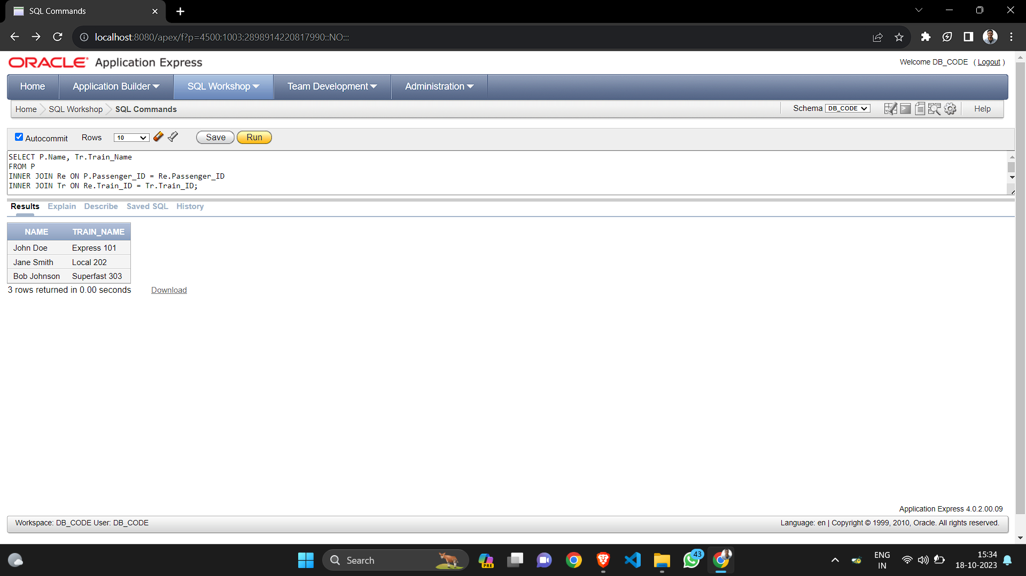

1. **Left join**

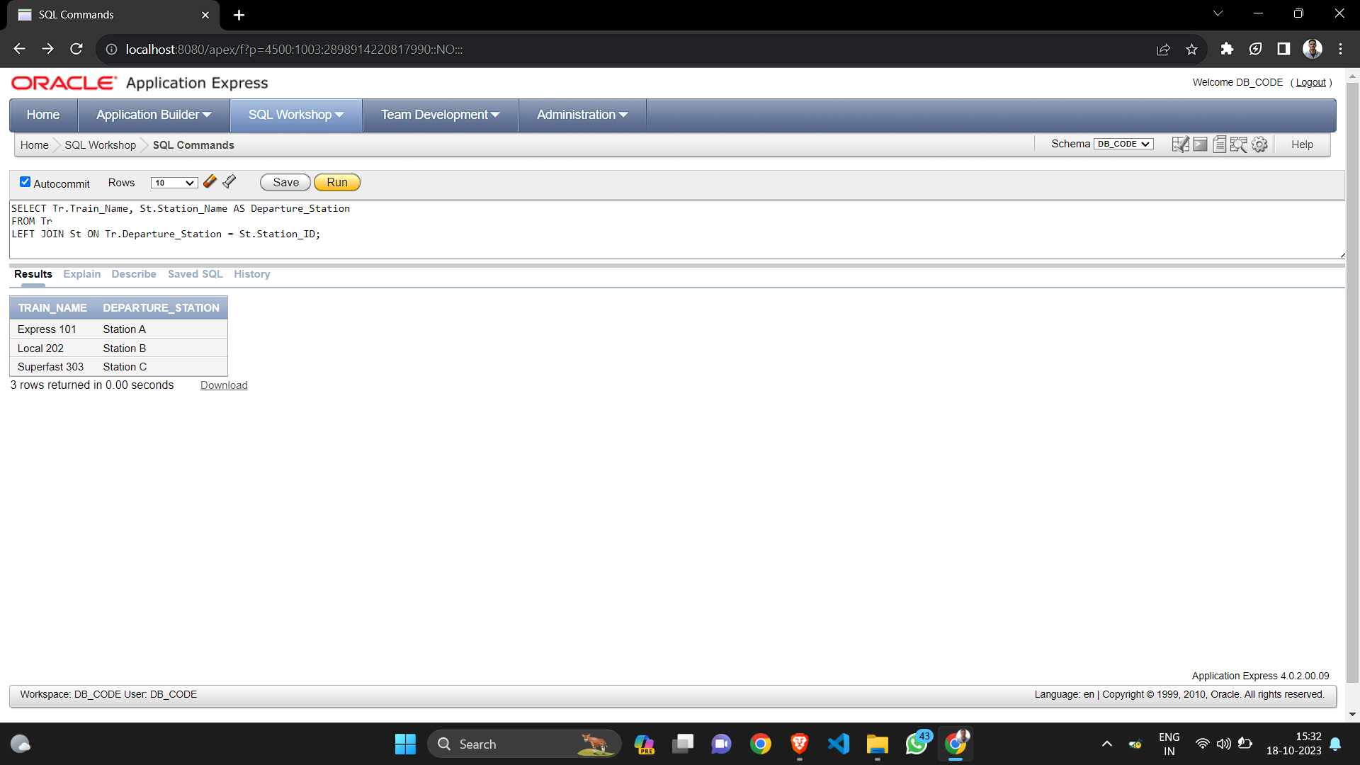

1. **Right join**

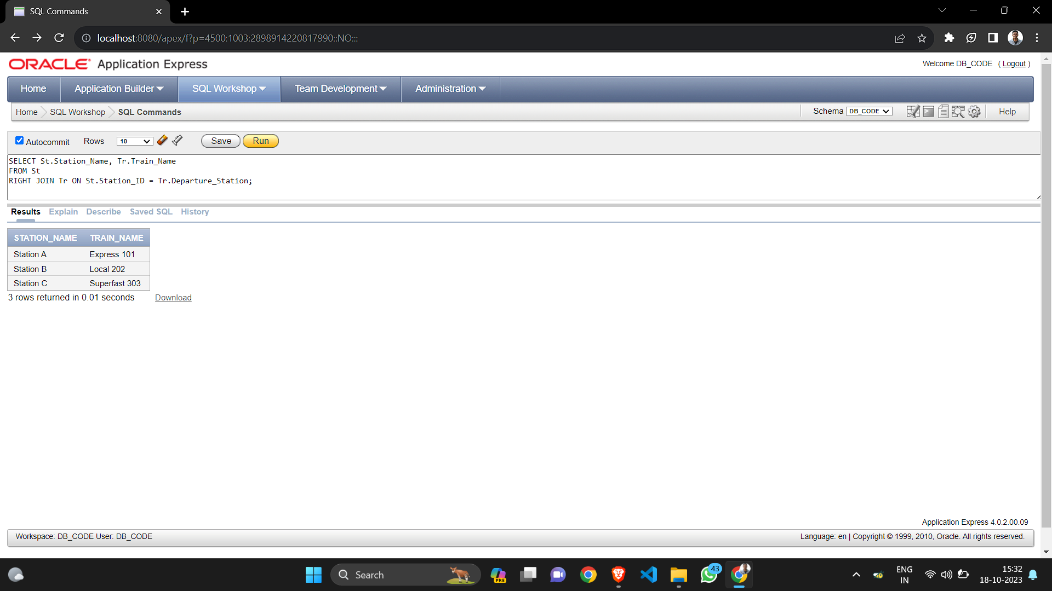

1. **Self join**

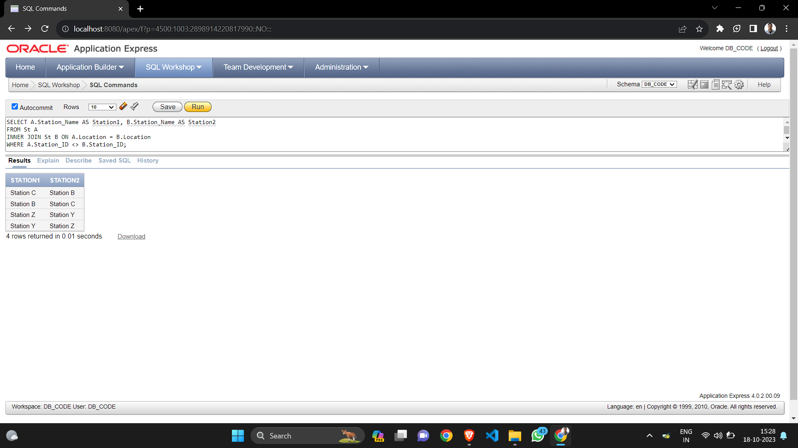

1. **Cross join**

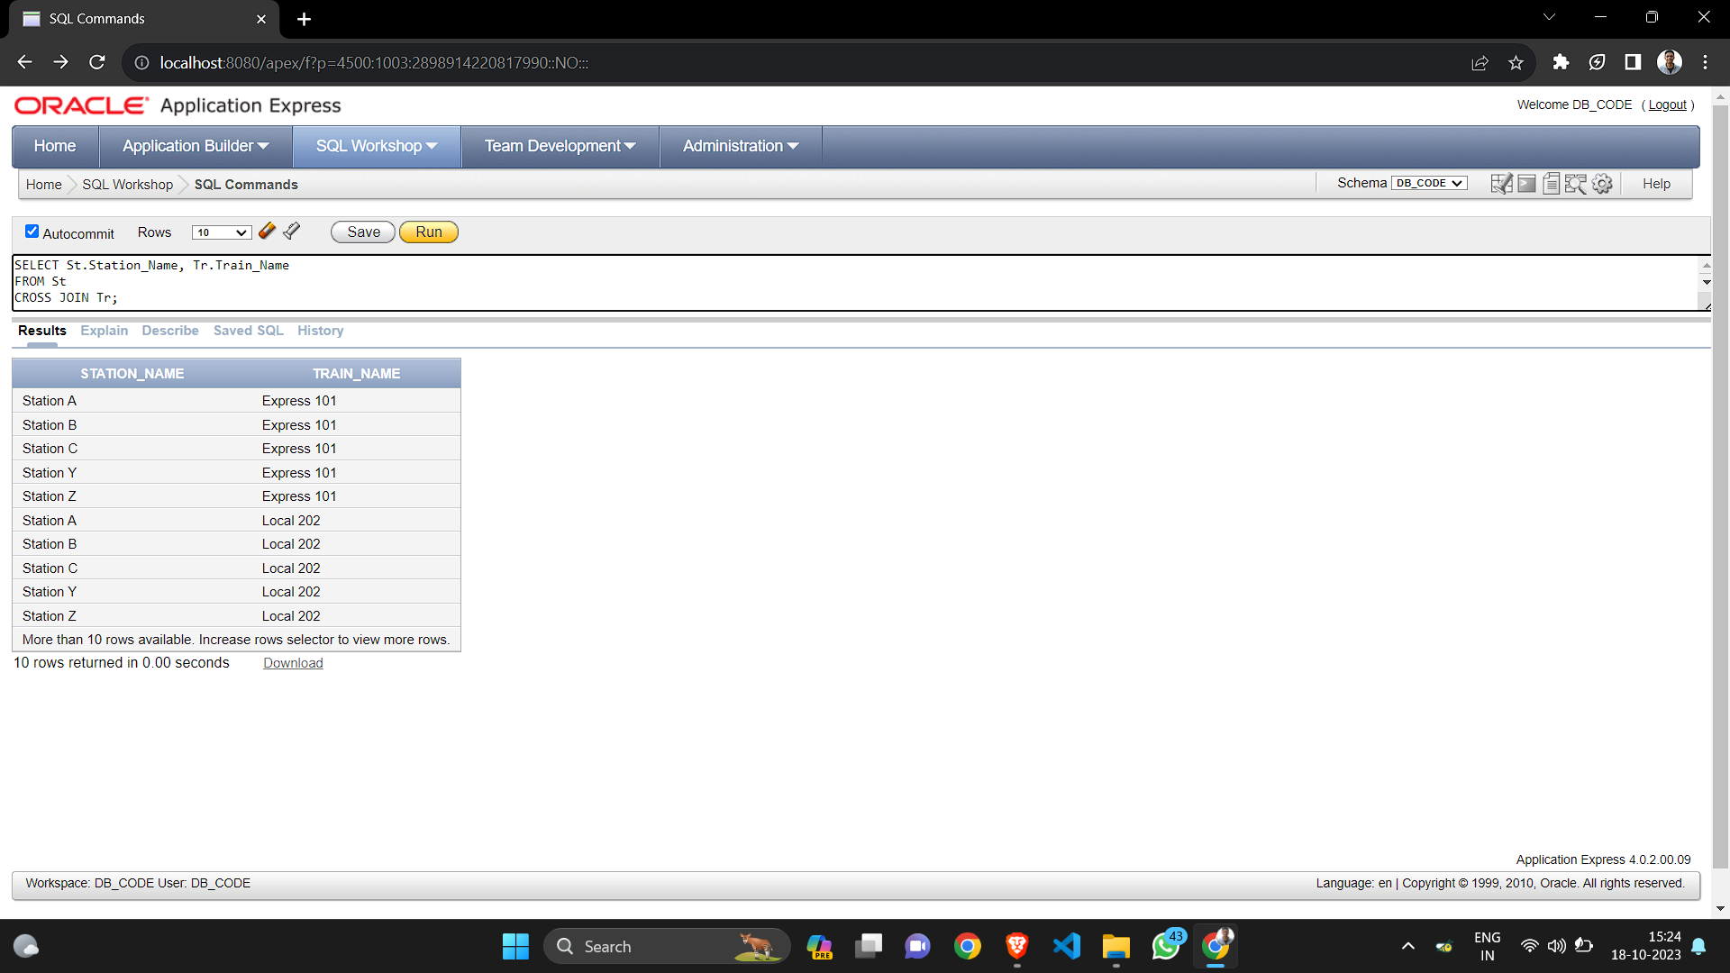

1. **Self Join for Hierarchy**

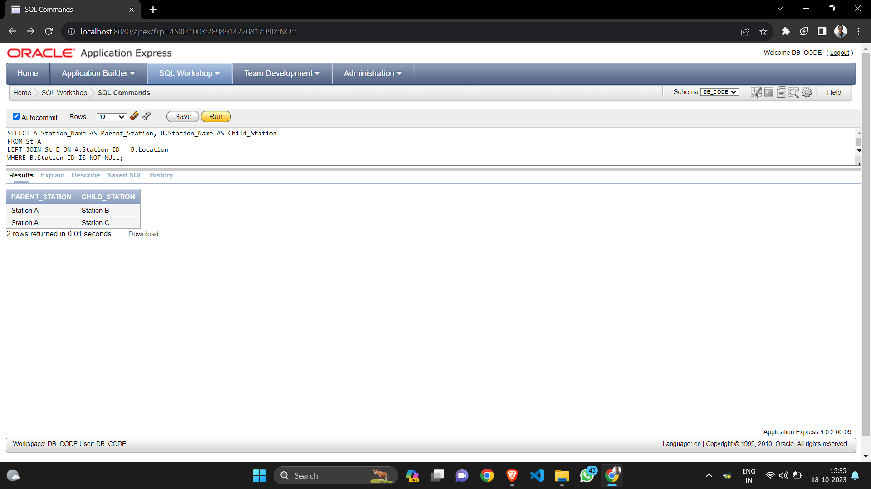

1. **Join with multiple condition**

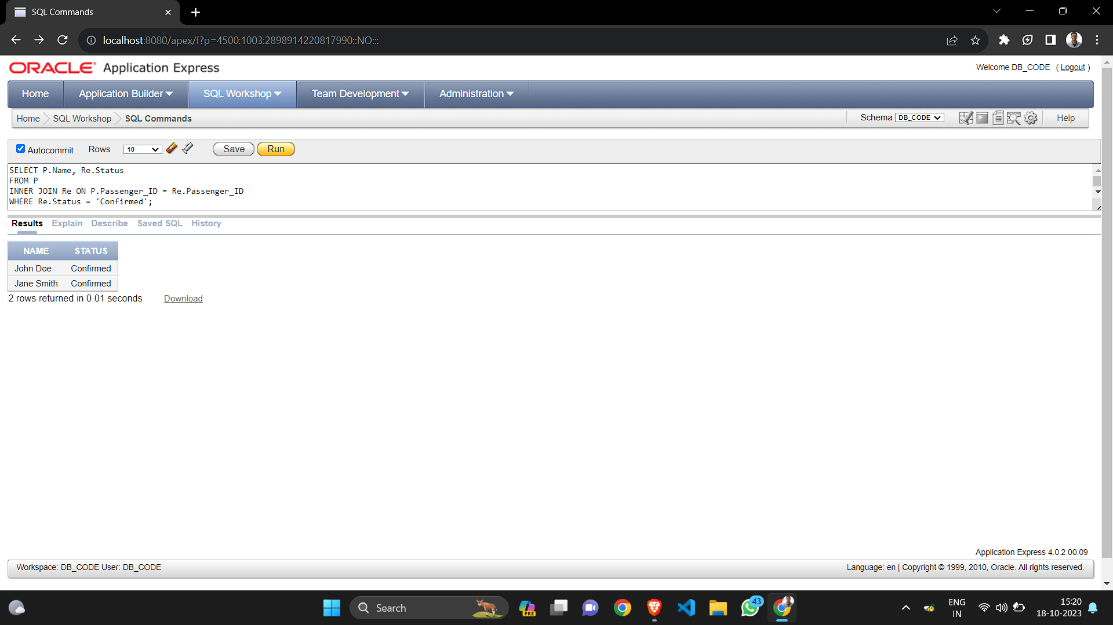

1. **Join with subquery**

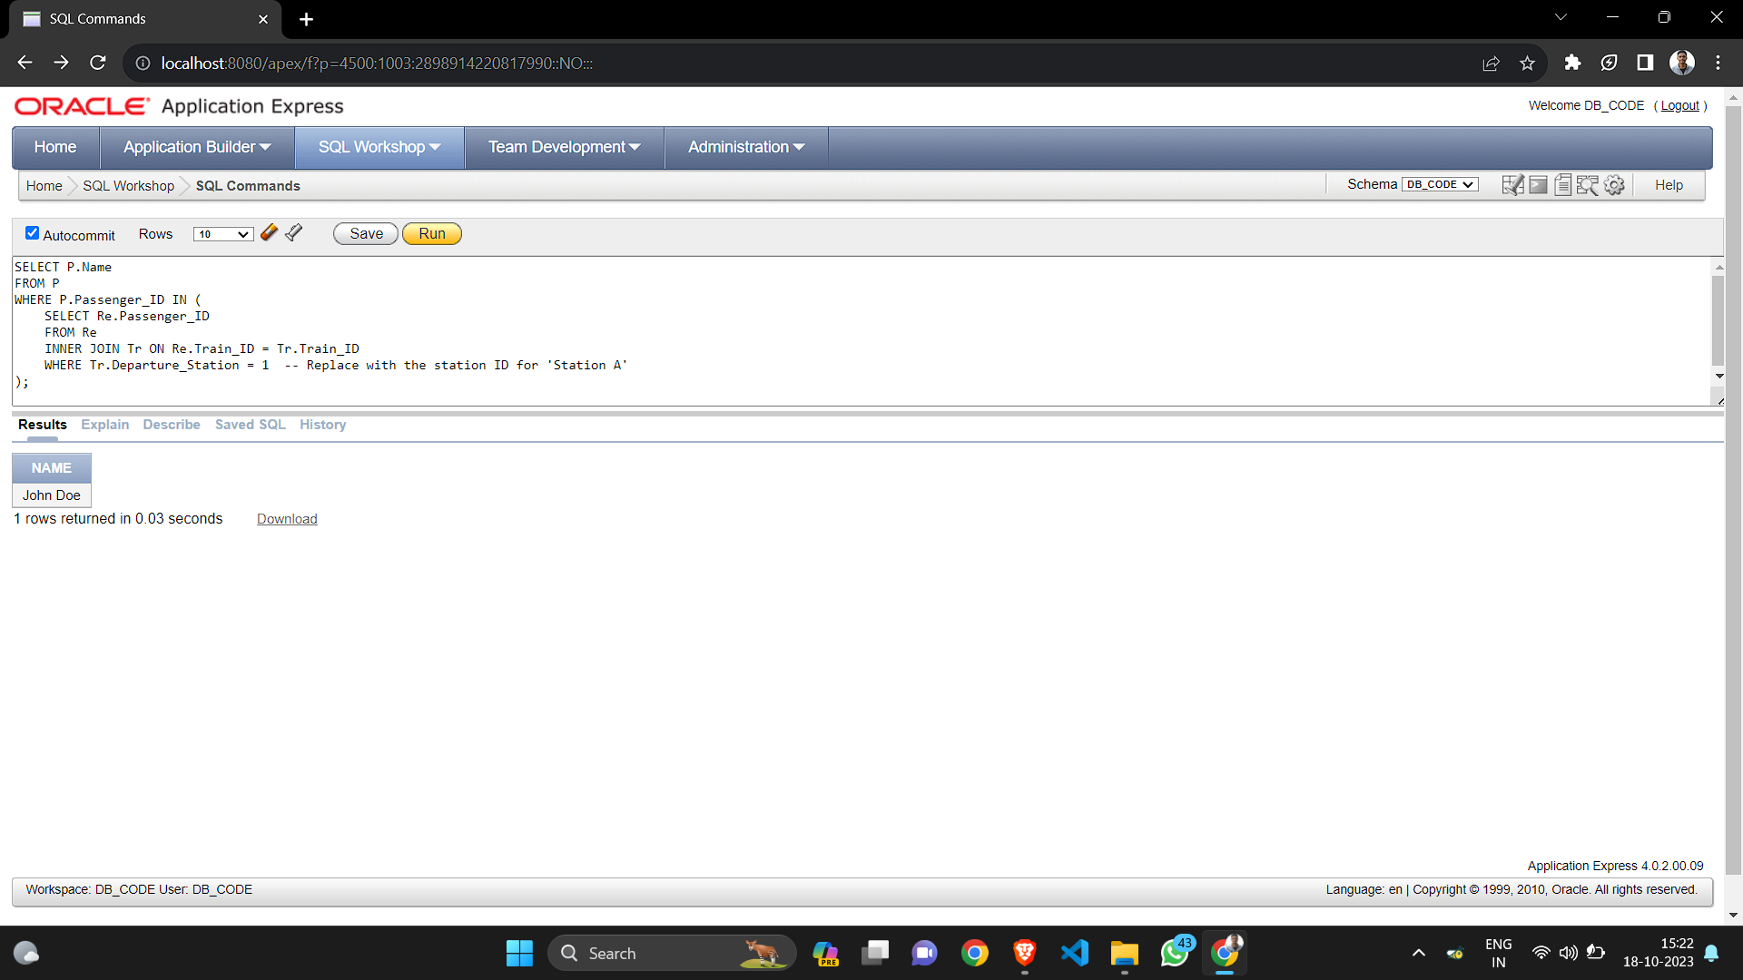

1. **Join with aggregation**

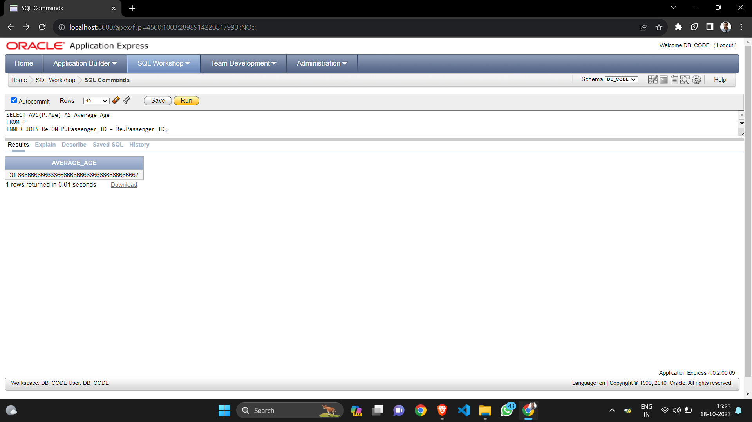

1. **Full outer join**

